SMART AGRICULTURE AND

FARMER ASSISTANCE SYSTEM

21CSC205P Database Management Systems
A MINI PROJECT REPORT

Submitted by
TANGUDU SATHWIK [RA2411026010727]
VANJAVAKA SRI NEHA REDDY [RA2411026010745]

Under the Guidance of

Dr. Kanipriya M
(Assistant Professor, Department of Computational Intelligence)

in partial fulfillment of the requirements for the degree of

BACHELOR OF TECHNOLOGY

in

COMPUTER SCIENCE ENGINEERING

with specialization in Artificial Intelligence & Machine Learning


DEPARTMENT OF COMPUTATIONAL INTELLIGENCE

SCHOOL OF COMPUTING

COLLEGE OF ENGINEERING AND TECHNOLOGY
SRM INSTITUTE OF SCIENCE AND TECHNOLOGY

KATTANKULATHUR- 603 203

MAY 2026


SRM INSTITUTE OF SCIENCE AND TECHNOLOGY KATTANKULATHUR – 603 203

BONAFIDE CERTIFICATE

Certified that Project report titled “SMART AGRICULTURE FARMER ASSISTANCE SYSTEM” is the Bonafide work of “TANGUDU SATHWIK [RA2411026010727], VANJAVAKA SRI NEHA REDDY [RA2411026010745]” who carried out the 21CSC205P Database Management Systems mini project work under my supervision.

Dr. Kanipriya M | HEAD OF THE DEPARMENT
Assistant Professor  Department of Computational Intelligence | PROFESSOR AND HEAD  Department

ABSTRACT

Agriculture is a critical sector that supports economic growth and food security, especially in developing countries where a large population depends on farming. However, farmers face numerous challenges such as lack of scientific crop guidance, poor soil health management, unpredictable weather conditions, limited access to market information, and insufficient awareness of government schemes. These issues are often worsened by fragmented data sources and manual record-keeping, leading to reduced productivity, crop losses, and financial instability. This highlights the need for an integrated and structured agricultural information system.
The Smart Agriculture & Farmer Assistance System (SAFAS) is designed as a centralized database-driven platform that supports farmers in making informed decisions throughout the agricultural lifecycle. The system manages farmer profiles, land details, soil test reports, crop planning, weather data, irrigation schedules, fertilizer recommendations, pest and disease reports, market prices, sales records, and financial assistance such as subsidies and loans. By connecting farmers, agricultural officers, soil testing laboratories, market vendors, and government administrators on a single platform, the system ensures better coordination, data accessibility, and operational efficiency.
The system is implemented using MySQL and follows a fully normalized relational database design up to Third Normal Form (3NF) to eliminate redundancy and maintain data integrity. Various entities are linked through primary and foreign key constraints, enabling efficient data retrieval and management. Advanced DBMS concepts such as triggers, stored procedures, views, indexing, and transaction management are incorporated to automate fertilizer recommendations, generate weather alerts, crop suitability, and provide role-based dashboards for users.

The architecture of the system allows easy scalability and future enhancements without altering the core database structure. The platform can be extended to integrate IoT-based sensors for real-time soil moisture and weather monitoring, mobile applications for farmer accessibility, and advanced analytics for yield prediction and risk assessment. Such enhancements would further strengthen decision support capabilities and improve the effectiveness of technology-driven agricultural management.

TABLE OF CONTENTS

Chapter No. | Title | Page no.

1
  - Introduction 9
  - Motivation 9
  - Scope 10
  - Problem Statement 10
  - Project Requirements 10
  - Identification of Entity and Relationships 11
  - Construction of DB Using ER Model for the Smart Agriculture and farmer assistance system 11

2

2.1 Relational Schema for Smart Agriculture And Farmer Assistance System
2.2 Description of Tables
2.3 Creation of Database and Tables - DDL Commands
2.4 Insertion of tuples into the table – DML commands

3
3.1 Adding Constraints and queries based on constraints
3.2 Queries based on Aggregate Functions
3.3 Complex queries based on Sets
3.4 Complex queries based on Subqueries
3.5 Complex queries based on Joins
3.6 Complex queries based on Views
3.7 Complex queries based on Triggers
3.8 Complex queries based on Cursors

4
4.1 Analyse the Pitfalls in Realtions
4.2 First Normal Form
4.3 Second Normal Form
4.4 Third Normal Form
4.5 BCNF
4.6 Fourth Normal Form
4.7 Fifth Normal Form
5
5.1 Introduction to Transactions
5.2 Transaction Copntrol Language (TCL)
5.3 Transaction Code With Output

6
6.1 Front -End Modules Code
6.2 Database Connectivity
7
7.1 Screenshots of front end
7.2 Screenshotts of Database

LIST OF FIGURES

Figure No. | Name | Page no.
1.1 | ER diagram of SAFAS | 10
2.1 | RELATIONAL SCHEMA For SAFAS | 11
3
4
5

LIST OF TABLES

Figure No. | Name | Page no.
1

2.4.1 USER TABLE 21
2.4.2 FARMER TABLE 21
2.4.3 LOAN TABLE 22
2.4.4 SUBSIDY TABLE 22
2.4.5 MARKET_PRICE TABLE 22
2.4.6 CROP_SALE TABLE 23
2.4.7 CROP_PLAN TABLE 23
2.4.8 LAND TABLE 23
2.4.9 IRRIGATION_SCHEDULE TABLE 23
2.4.10 MARKET TABLE 24
2.4.11 LOAN_APPLICATION TABLE 24
2.4.12 SUBSIDY_APPLICATION 24
2.4.13 SOIL_REPORT TABLE 25
2.4.14 CROP TABLE 25
2.4.15 WEATHER_DATA TABLE 25

2
3
4

CHAPTER 1

PROBLEM UNDERSTANDING, IDENTIFICATION OF ENTITY AND RELATIONSHIPS, CONSTRUCTION OF DB USING ER MODEL FOR THE SMART AGRICULTURE AND FARMER ASSISTANCE SYSTEM

  - Introduction: -

Agriculture is a vital sector that supports food security and economic growth, especially in developing countries. Farmers face challenges such as lack of crop guidance, poor soil management, unpredictable weather, and limited market transparency. These problems are further intensified by scattered information systems and manual record-keeping practices. As a result, farmers often experience reduced productivity and financial losses. There is a strong need for a structured and technology-driven agricultural support system.

The Smart Agriculture & Farmer Assistance System (SAFAS) is a centralized, database-driven platform designed to address these challenges. It manages farmer data, land records, soil reports, crop planning, weather information, market prices, and government schemes. The system also supports irrigation guidance, fertilizer recommendations, and pest management. Developed using MySQL, it ensures data integrity, consistency, and scalability. The platform enables data-driven agricultural decision-making and improved coordination among stakeholders.

  - Motivation: -

The motivation behind developing the Smart Agriculture & Farmer Assistance System (SAFAS) arises from several real-world agricultural and technical challenges
- Many farmers still depend on traditional farming methods without access to scientific crop, soil, and weather information, leading to low productivity.
- Improper soil management, unplanned fertilizer usage, and inefficient irrigation practices result in soil degradation and increased farming costs.
- Unpredictable weather conditions and pest or disease outbreaks cause significant crop losses due to the lack of timely alerts and guidance
- Farmers often face exploitation due to lack of transparency in market prices, subsidies, and agricultural loan information.
- From an academic perspective, the project provides an opportunity to design and implement a real-world database application using DBMS concepts such as ER modelling, normalization, SQL queries, constraints, triggers, stored procedures, and transaction management.

  - Scope: -

The scope of the Smart Agriculture & Farmer Assistance System covers both functional and technical aspects of agricultural management. The system supports:
- Secure registration and role-based access for farmers, agricultural officers, market vendors, and government administrators.
- Management of farmer profiles, land details, soil test reports, and crop planning information.
- Soil-based fertilizer recommendations and irrigation scheduling to promote efficient resource utilization.
- Storage and analysis of weather data for crop planning and risk reduction.
- Market price tracking and maintenance of crop sales records to ensure price transparency.
- Management of government subsidies and agricultural loans, including application and approval status.
- Generation of analytical reports related to crop yield, soil health, market trends, and subsidy utilization.
- A normalized and well-structured MySQL database design ensuring data integrity, consistency, and scalability.

  - Problem Statement: -

The problem is to design and implement a database-driven agricultural management system that assists farmers in making informed and data-driven farming decisions. The system must efficiently store and manage data related to farmers, land, soil health, crops, weather conditions, irrigation, fertilizers, pests, markets, subsidies, and loans. It should provide timely recommendations, alerts, and analytical insights while ensuring secure access and data consistency. The solution must be scalable, reliable, and based on proper DBMS principles to meet real-world agricultural requirements.

  - Project Requirements: -

The essential requirements of the Smart Agriculture & Farmer Assistance System include:
- Secure login and authentication mechanisms with role-based access control
- Functionality to register and manage farmer, land, and soil test information.
- Crop planning features based on season, soil condition, and weather data.
- Automated fertilizer recommendations and irrigation guidance.
- Market price management and maintenance of crop sales records.
- Management of subsidy and loan schemes along with farmer applications.
- Generation of reports and dashboards for farmers and administrators.
- Secure data storage and retrieval using MySQL, ensuring normalization, integrity constraints, indexing, and transaction control.

  - Identification of Entity and Relationships: -

To accurately model the system, several key entities are identified, including Farmer, Land, Soil Report, Crop, Crop Season, Crop Plan, Weather Data, Fertilizer, Pest, Crop Disease, Market, Crop Price, Sale Record, Subsidy, Loan, Notification, and Login Credentials. Each entity represents a real-world agricultural component with well-defined attributes. Relationships among entities include one-to-many and many-to-many associations, such as a farmer owning multiple lands, crops being grown across different seasons, and farmers applying for multiple subsidies or loans. Participation constraints are applied to reflect real-world dependencies, for example, every soil report must be associated with a land, while a farmer may or may not apply for a subsidy or loan.

  - Construction of DB Using ER Model for the SMART AGRICLUTURE AND FARMER ASSISTANCE –

The construction of the database using the ER model for the Smart Agriculture and Farmer Assistance System is derived directly from the entities, attributes, and relationships shown in the ER diagram. Core entities such as User, Farmer, Land, Crop, Market, Loan, Subsidy, Weather_Data, and Soil_Report are identified and converted into relational tables with clearly defined primary keys to ensure entity uniqueness. One-to-many relationships, such as a farmer owning multiple lands or a land having multiple soil reports, are implemented using foreign keys, while many-to-many relationships like farmers applying for loans or subsidies are resolved through associative tables such as Loan_Application and Subsidy_Application. Attributes represented as multivalued or composite in the ER diagram are normalized into atomic fields to maintain data consistency and eliminate redundancy. Constraints such as NOT NULL, UNIQUE, CHECK, and ENUM are applied to enforce domain rules and data integrity. Overall, the ER model provides a structured blueprint that ensures the resulting database is normalized, scalable, and capable of efficiently supporting agricultural planning, financial assistance, market monitoring, and decision-making processes within the smart agriculture system.

Figure 1.1: ER diagram of SMART AGRICLUTURE AND FARMER ASSISTANCE

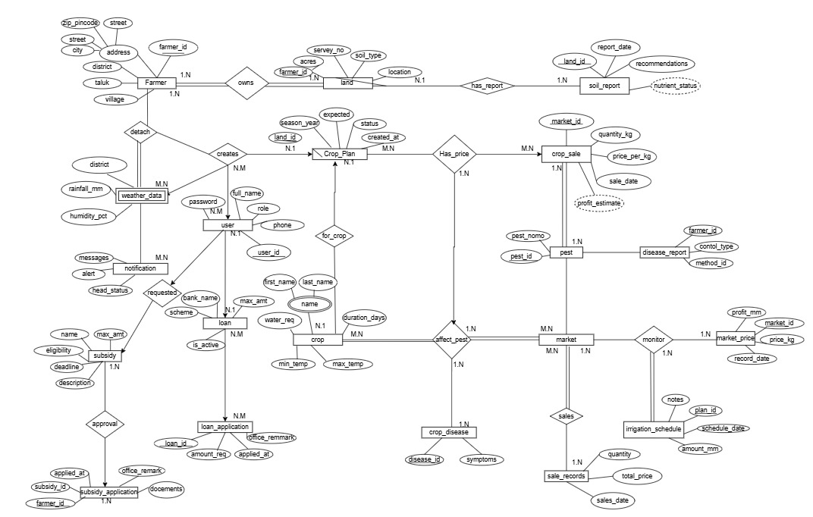

Chapter 2
Design of Relational Schemas, Creation of Database and Tables for SMART AGRICLUTURE AND FARMER ASSISTANCE

2.1 Relational Schema for SMART AGRICLUTURE AND FARMER ASSISTANCE:-
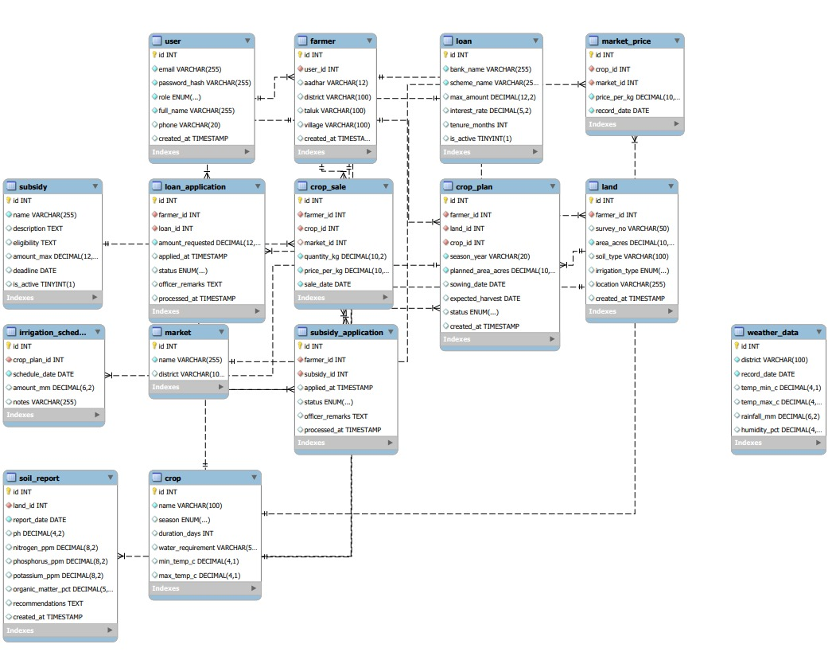

Figure 2.1: Relational Schema for Smart Agriculture and Farmer Assistance System
Figure 2.1 illustrates the relational schema diagram of the Smart Agriculture and Farmer Assistance System showing how different entities are interconnected to support agricultural operations and farmer welfare. The diagram clearly represents multiple tables such as user, farmer, land, crop, crop_plan, market, loan, subsidy, and weather_data, each designed to store specific information. Primary keys uniquely identify records in each table, while foreign keys establish relationships that ensure data integrity and logical consistency across the system.
User and farmer entities form the foundation of the system. The user table manages authentication details such as email, password, role, and account creation time, enabling role-based access to the system. The farmer table is linked to the user table and stores agricultural identity details like Aadhaar number, village, taluk, and contact information. This relationship ensures that every farmer account is securely associated with a valid user profile and enables centralized user management.
Land and crop-related tables represent the agricultural domain of the system. The land table stores details about agricultural land owned by farmers, including survey number, area, soil type, irrigation type, and location. The crop and crop_plan tables are connected to land and farmer records, allowing farmers to plan crops season-wise with expected yields, sowing dates, and status tracking. The soil_report table further enhances decision-making by storing soil nutrient levels and recommendations for specific lands.
Market and sales activities are modeled through market, market_price, and crop_sale tables. The market table stores market location details, while the market_price table records daily crop prices for each market. The crop_sale table links farmers, crops, and markets to record sales transactions including quantity, price, and sale date. These relationships allow farmers to compare prices, track income, and analyze market trends over time.
Financial and environmental support components are represented using loan, loan_application, subsidy, subsidy_application, irrigation_schedule, and weather_data tables. Loan and subsidy tables store scheme details, while their respective application tables track farmer requests and approval status. The irrigation_schedule table manages water usage plans for crops, and the weather_data table records district-wise climate conditions such as temperature, rainfall, and humidity. Together, these interconnected tables demonstrate a comprehensive, well-normalized relational schema that supports smart farming, financial assistance, and data-driven agricultural management.

.

2.2 Description of Tables: -

Table 2.2.1: User
Purpose: stores common information of all the users in the system
Primary Key: user_id (INTEGER)
Data Types and Constraints:
- user_id – INTEGER, PRIMARY KEY, NOT NULL, AUTO_INCREMENT
- name – VARCHAR (100), NOT NULL
- email – VARCHAR (150), NOT NULL, UNIQUE
- password_hash – VARCHAR (255), NOT NULL
- date_of_birth – DATE
- gender – ENUM ('Male', 'Female', 'Others')
- preferred_theme – ENUM ('LIGHT', 'DARK'), DEFAULT 'LIGHT'

Table 2.2.2: Farmer
Purpose: stores farmer personal and identity details.
Primary Key: farmer_id
Data Types and Constraints:
- farmer_id – INT, PK, AUTO_INCREMENT
- name – VARCHAR (100), NOT NULL
- aadhaar_no – CHAR (12), UNIQUE, NOT NULL
- phone – VARCHAR (15), NOT NULL
- village – VARCHAR (100), NOT NULL
- district – VARCHAR (100), NOT NULL
- state – VARCHAR (100), NOT NULL

Table 2.2.3: loan
Purpose: stores loan scheme information
Primary Key: loan_id
Data Types and Constraints:
- loan_id – INT, PRIMARY KEY, AUTO_INCREMENT
- loan_type – VARCHAR (100), NOT NULL
- interest_rate – FLOAT, NOT NULL
- max_amount – DECIMAL (10,2), NOT NULL

Table 2.2.4: subsidy
Purpose: Stores government subsidy schemes.
Primary Key: subsidy_id
Data Types and Constraints:
- subsidy_id – INT, PRIMARY KEY, AUTO_INCREMENT
- scheme_name – VARCHAR (150), UNIQUE, NOT NULL
- eligibility – TEXT, NOT NULL
- subsidy_amount – DECIMAL (10,2), NOT NULL

Table 2.2.5: Market_Price
Purpose: Stores daily crop price details in markets.
Primary Key: price_id (INTEGER)
Data Types and Constraints:
- price_id – INTEGER, PRIMARY KEY, NOT NULL, AUTO_INCREMENT
- crop_id – INTEGER, FOREIGN KEY → Crop(crop_id), NOT NULL
- market_id – INTEGER, FOREIGN KEY → Market(market_id), NOT NULL
- price_per_quintal – DECIMAL (8,2), NOT NULL
- date – DATE, NOT NULL

Table 2.2.6: Crop_Sale
Purpose: Stores crop selling transaction records.
Primary Key: sale_id (INTEGER)
Data Types and Constraints:
- sale_id – INTEGER, PRIMARY KEY, NOT NULL, AUTO_INCREMENT
- farmer_id – INTEGER, FOREIGN KEY → Farmer(farmer_id), NOT NULL
- crop_id – INTEGER, FOREIGN KEY → Crop(crop_id), NOT NULL
- market_id – INTEGER, FOREIGN KEY → Market(market_id), NOT NULL
- quantity – DECIMAL (8,2), NOT NULL
- total_price – DECIMAL (10,2), NOT NULL
- sale_date – DATE, NOT NULL

Table 2.2.7: Crop_Plan
Purpose: Stores crop planning details of farmers for each season.
Primary Key: plan_id (INTEGER)
Data Types and Constraints:
- plan_id – INTEGER, PRIMARY KEY, NOT NULL, AUTO_INCREMENT
- land_id – INTEGER, FOREIGN KEY → Land(land_id), NOT NULL
- crop_id – INTEGER, FOREIGN KEY → Crop(crop_id), NOT NULL
- season – VARCHAR (50), NOT NULL
- expected_yield – DECIMAL (8,2), NOT NULL
- status – ENUM('Planned','Growing','Completed'), DEFAULT 'Planned'

Table 2.2.8: land
Purpose: Stores land owned by farmers.
Primary Key: land_id (INTEGER)
Data Types and Constraints:
- land_id – INTEGER, PRIMARY KEY, NOT NULL, AUTO_INCREMENT
- farmer_id – INTEGER, FOREIGN KEY → Farmer(farmer_id), NOT NULL
- area_acres – DECIMAL (6,2), NOT NULL
- soil_type – VARCHAR (50), NOT NULL
- irrigation_available – BOOLEAN, DEFAULT FALSE

Table 2.2.9: Irrigation_Schedule
Purpose: Stores irrigation scheduling details for crops.
Primary Key: schedule_id (INTEGER)
Data Types and Constraints:
- schedule_id – INTEGER, PRIMARY KEY, NOT NULL, AUTO_INCREMENT
- land_id – INTEGER, FOREIGN KEY → Land(land_id), NOT NULL
- crop_id – INTEGER, FOREIGN KEY → Crop(crop_id), NOT NULL
- frequency – VARCHAR (50), NOT NULL
- water_quantity – DECIMAL (6,2), NOT NULL
Table 2.2.10: Market
Purpose: Stores market information
Primary Key: market_id (INTEGER)
Data Types and Constraints:
- market_id – INTEGER, PRIMARY KEY, NOT NULL, AUTO_INCREMENT
- market_name – VARCHAR (100), NOT NULL
- location – VARCHAR (150), NOT NULL

Table 2.2.11: Loan_Application
Purpose: Stores loan applications submitted by farmers
Primary Key: application_id (INTEGER)
Data Types and Constraints:
- application_id – INTEGER, PRIMARY KEY, NOT NULL, AUTO_INCREMENT
- farmer_id – INTEGER, FOREIGN KEY → Farmer(farmer_id), NOT NULL
- loan_id – INTEGER, FOREIGN KEY → Loan(loan_id), NOT NULL
- amount_requested – DECIMAL (10,2), NOT NULL
- status – ENUM('Pending','Approved','Rejected'), DEFAULT 'Pending'

Table 2.2.12: Subsidy_Application
Purpose: Stores subsidy applications submitted by farmers.
Primary Key: application_id (INTEGER)
Data Types and Constraints:
- application_id – INTEGER, PRIMARY KEY, NOT NULL, AUTO_INCREMENT
- farmer_id – INTEGER, FOREIGN KEY → Farmer(farmer_id), NOT NULL
- subsidy_id – INTEGER, FOREIGN KEY → Subsidy(subsidy_id), NOT NULL
- status – ENUM('Pending','Approved','Rejected'), DEFAULT 'Pending'

Table 2.2.13: Soil_Report
Purpose: Stores soil testing results for each land.
Primary Key: report_id (INTEGER)
Data Types and Constraints:
- report_id – INTEGER, PRIMARY KEY, NOT NULL, AUTO_INCREMENT
- land_id – INTEGER, FOREIGN KEY → Land(land_id), NOT NULL
- ph_value – DECIMAL (3,1), CHECK (ph_value BETWEEN 0 AND 14)
- nitrogen – FLOAT, NOT NULL
- phosphorus – FLOAT, NOT NULL
- potassium – FLOAT, NOT NULL
- report_date – DATE, NOT NULL

Table 2.2.14: Crop
Purpose: Stores crop master information.
Primary key: crop_id (INTEGER)
Data Types and Constraints:
- crop_id – INTEGER, PRIMARY KEY, NOT NULL, AUTO_INCREMENT
- crop_name – VARCHAR (100), UNIQUE, NOT NULL
- crop_type – VARCHAR (50), NOT NULL
- avg_growth_days – INTEGER, NOT NULL

Table 2.2.15: Weather_Data
Purpose: Stores district-level weather information.
Primary key: weather_id (INTEGER)
Data Types and Constraints:
- weather_id – INTEGER, PRIMARY KEY, NOT NULL, AUTO_INCREMENT
- district – VARCHAR (100), NOT NULL
- date – DATE, NOT NULL
- temperature – FLOAT, NOT NULL
- rainfall – FLOAT, DEFAULT 0
- humidity – FLOAT, NOT NULL

2.3 Creation of Database and Tables - DDL Commands

- 1. USER TABLE: -

CREATE TABLE user (

user_id INT PRIMARY KEY AUTO_INCREMENT,

name VARCHAR (100) NOT NULL,

email VARCHAR (150) UNIQUE NOT NULL,

password_hash VARCHAR (255) NOT NULL,

date_of_birth DATE,

gender ENUM('Male','Female','Others'),

preferred_theme ENUM('LIGHT','DARK') DEFAULT 'LIGHT'

);

- 2. FARMER TABLE: -

CREATE TABLE farmer (

farmer_id INT PRIMARY KEY AUTO_INCREMENT,

name VARCHAR (100) NOT NULL,

aadhaar_no CHAR (12) UNIQUE NOT NULL,

phone VARCHAR (15) NOT NULL,

village VARCHAR (100) NOT NULL,

district VARCHAR (100) NOT NULL,

state VARCHAR (100) NOT NULL

);

- 3 LOAN TABLE: -

CREATE TABLE loan (

loan_id INT PRIMARY KEY AUTO_INCREMENT,

loan_type VARCHAR (100) NOT NULL,

interest_rate FLOAT NOT NULL,

max_amount DECIMAL (10,2) NOT NULL

);

- 4. SUBSIDY TABLE: -

CREATE TABLE subsidy (

subsidy_id INT PRIMARY KEY AUTO_INCREMENT,

scheme_name VARCHAR (150) UNIQUE NOT NULL,

eligibility TEXT NOT NULL,

subsidy_amount DECIMAL (10,2) NOT NULL

);

- 5.MARKET_PRICE TABLE: -

CREATE TABLE market_price (

price_id INT PRIMARY KEY AUTO_INCREMENT,

crop_id INT NOT NULL,

market_id INT NOT NULL,

price_per_quintal DECIMAL (8,2) NOT NULL,

date DATE NOT NULL,

FOREIGN KEY (crop_id) REFERENCES crop(crop_id),

FOREIGN KEY (market_id) REFERENCES market(market_id)

);

- 6. CROP_SALE TABLE: -

CREATE TABLE crop_sale (

sale_id INT PRIMARY KEY AUTO_INCREMENT,

farmer_id INT NOT NULL,

crop_id INT NOT NULL,

market_id INT NOT NULL,

quantity DECIMAL(8,2) NOT NULL,

total_price DECIMAL(10,2) NOT NULL,

sale_date DATE NOT NULL,

FOREIGN KEY (farmer_id) REFERENCES farmer(farmer_id),

FOREIGN KEY (crop_id) REFERENCES crop(crop_id),

FOREIGN KEY (market_id) REFERENCES market(market_id)

);

- 7. CROP_PLAN TABLE: -

CREATE TABLE crop_plan (

plan_id INT PRIMARY KEY AUTO_INCREMENT,

land_id INT NOT NULL,

crop_id INT NOT NULL,

season VARCHAR(50) NOT NULL,

expected_yield DECIMAL(8,2) NOT NULL,

status ENUM('Planned','Growing','Completed') DEFAULT 'Planned',

FOREIGN KEY (land_id) REFERENCES land(land_id),

FOREIGN KEY (crop_id) REFERENCES crop(crop_id)

);

- 8. LAND TABLE: -

CREATE TABLE land (

land_id INT PRIMARY KEY AUTO_INCREMENT,

farmer_id INT NOT NULL,

area_acres DECIMAL(6,2) NOT NULL,

soil_type VARCHAR(50) NOT NULL,

irrigation_available BOOLEAN DEFAULT FALSE,

FOREIGN KEY (farmer_id) REFERENCES farmer(farmer_id)

);

- 9. IRRIGATION_SCHEDULE TABLE: -

CREATE TABLE irrigation_schedule (

schedule_id INT PRIMARY KEY AUTO_INCREMENT,

land_id INT NOT NULL,

crop_id INT NOT NULL,

frequency VARCHAR(50) NOT NULL,

water_quantity DECIMAL(6,2) NOT NULL,

FOREIGN KEY (land_id) REFERENCES land(land_id),

FOREIGN KEY (crop_id) REFERENCES crop(crop_id)

);

- 10. MARKET TABLE: -

CREATE TABLE market (

market_id INT PRIMARY KEY AUTO_INCREMENT,

market_name VARCHAR (100) NOT NULL,

location VARCHAR (150) NOT NULL

);

- 11.LOAN_APPLICATION TABLE: -

CREATE TABLE loan_application (

application_id INT PRIMARY KEY AUTO_INCREMENT,

farmer_id INT NOT NULL,

loan_id INT NOT NULL,

amount_requested DECIMAL (10,2) NOT NULL,

status ENUM('Pending','Approved','Rejected') DEFAULT 'Pending',

FOREIGN KEY (farmer_id) REFERENCES farmer(farmer_id),

FOREIGN KEY (loan_id) REFERENCES loan(loan_id)

);

- 12. SUBSIDY_APPLICATION TABLE: -

CREATE TABLE subsidy_application (

application_id INT PRIMARY KEY AUTO_INCREMENT,

farmer_id INT NOT NULL,

subsidy_id INT NOT NULL,

status ENUM('Pending','Approved','Rejected') DEFAULT 'Pending',

FOREIGN KEY (farmer_id) REFERENCES farmer(farmer_id),

FOREIGN KEY (subsidy_id) REFERENCES subsidy(subsidy_id)

);

- 13. SOIL_REPORT TABLE: -

CREATE TABLE soil_report (

report_id INT PRIMARY KEY AUTO_INCREMENT,

land_id INT NOT NULL,

ph_value DECIMAL (3,1) CHECK(ph_value BETWEEN 0 AND 14),

nitrogen FLOAT NOT NULL,

phosphorus FLOAT NOT NULL,

potassium FLOAT NOT NULL,

report_date DATE NOT NULL,

FOREIGN KEY (land_id) REFERENCES land(land_id)

);

- 14. CROAP TABLE: -

CREATE TABLE crop (

crop_id INT PRIMARY KEY AUTO_INCREMENT,

crop_name VARCHAR (100) UNIQUE NOT NULL,

crop_type VARCHAR (50) NOT NULL,

avg_growth_days INT NOT NULL

);
- 15.WEATHER_DATA TABLE: -

CREATE TABLE weather_data (

weather_id INT PRIMARY KEY AUTO_INCREMENT,

district VARCHAR(100) NOT NULL,

date DATE NOT NULL,

temperature FLOAT NOT NULL,

rainfall FLOAT DEFAULT 0,

humidity FLOAT NOT NULL

);

2.4 Insertion of tuples into the table – DML commands

1. USER TABLE
INSERT INTO user VALUES
(1, 'Ravi Kumar', 'ravi@gmail.com', 'Male', 'LIGHT'),
(2, 'Sita Devi', 'sita@gmail.com', 'Female', 'DARK');

user_id | name | email | gender | preferred_theme
1 | Ravi Kumar | ravi@gmail.com | Male | LIGHT
2 | Sita Devi | sita@gmail.com | Female | DARK

Table 2.4.1 USER TABLE
2.FARMER TABLE
INSERT INTO farmer (farmer_id, name, aadhaar_no, phone, village, district, state)
VALUES (1, ‘Ravi Kumar’, ‘123456789012’, ‘9876543210’, ‘Kothapet’, ‘Guntur’, ‘Andhra Pradesh’);

farmer_id | name | aadhaar_no | phone | village | district | state
1 | Ravi Kumar | 123456789012 | 9876543210 | Kothapet | Guntur | Andhra Pradesh

Table 2.4.2 FARMER TABLE

3. LOAN TABLE
INSERT INTO loan (loan_id, loan_type, interest_rate, max_amount)
VALUES (1, 'Crop Loan', 7.5, 500000);

loan_id | loan_type | interest_rate | max_amount
1 | Crop Loan | 7.5 | 500000

Table2.4.3 LOAN TABLE
4. SUBSIDY TABLE

INSERT INTO subsidy (subsidy_id, scheme_name, eligibility, subsidy_amount)
VALUES (1, 'PMFBY', 'Small Farmers', 20000);

subsidy_id | scheme_name | eligibility | subsidy_amount
1 | PMFBY | Small Farmers | 20000

Table2.4.4 SUBSIDY TABLE
5. MARKET_PRICE TABLE
INSERT INTO market_price (price_id, crop_id, market_id, price)
VALUES
(1, 1, 1, 2500),
(2, 2, 2, 2200);
price_id | crop_id | market_id | price
1 | 1 | 1 | 2500
2 | 2 | 2 | 2200

Table 2.4.5 MARKET_TABLE
6. CROP_SALE TABLE
INSERT INTO crop_sale (sale_id, farmer_id, crop_id, market_id, quantity, total_price, sale_date)
VALUES
(1, 1, 1, 1, 10, 25000, ‘2026-01-15’),
(2, 2, 2, 2, 20, 4500, ‘2026-01-25’);
sale_id | farmer_id | crop_id | market_id | quantity | total_price | sale_date
1 | 1 | 1 | 1 | 10 | 25000 | 2026-01-15
2 | 2 | 2 | 2 | 20 | 4500 | 2026-01-25

Table2.4.6 CROP_SALE TABLE

- CROP_PLAN Table
INSERT INTO crop_plan (plan_id, land_id, crop_id, season, expected_yield, status)
VALUES
(1, 1, 1, ‘Kharif’, 2000, ‘Growing’),
(2, 2, 2, ‘Cotton’, 3000, ‘Growing’);
plan_id | land_id | crop_id | season | expected_yield | status
1 | 1 | 1 | Kharif | 2000 | Growing
2 | 2 | 2 | cotton | 3000 | Growing

Table2.4.7 CROP_PLAN TABLE

8.LAND TABLE
INSERT INTO land (land_id, farmer_id, area_acres, soil_type, irrigation_available)
VALUES
(1, 1, 2.50, 'Loamy', TRUE);
land_id | farmer_id | area_acres | soil_type | irrigation_available
1 | 1 | 2.50 | Loamy | TRUE
Table2.4.8 LAND TABLE

9. IRRIGATION_SCHEDULE TABLE
INSERT INTO irrigation_schedule (schedule_id, land_id, crop_id, frequency, water_quantity)
VALUES
(1, 1, 1, 'Weekly', 500),
(2, 2, 2, 'Weekly', 700);
schedule_id | land_id | crop_id | frequency | water_quantity
1 | 1 | 1 | Weekly | 500
2 | 2 | 2 | Weekly | 700

Table2.4.9 IRRIGATION_SCHEDULE TABLE

10. MARKET TABLE
INSERT INTO market (market_id, market_name, location)
VALUES
(1, 'Central Market', 'Chennai');
market_id | market_name | location
1 | Central Market | Chennai

Table2.4.10 MARKET TABLE

11. LOAN_APPLICATION TABLE
INSERT INTO loan_application (application_id, farmer_id, loan_id, amount_requested, status)
VALUES
(1, 1, 1, 200000, 'Approved');
application_id | farmer_id | loan_id | amount_requested | status
1 | 1 | 1 | 200000 | Approved

Table2.4.11 LOAN_APPLICATION

12. SUBSIDY_APPLICATION TABLE
INSERT INTO subsidy_application (application_id, farmer_id, subsidy_id, status)
VALUES
(1, 1, 1, 'Pending'),
(2, 2, 2, 'Pending');
application_id | farmer_id | subsidy_id | status
1 | 1 | 1 | pending
2 | 2 | 2 | Pending

Table2.4.12 SUBSIDY_APPLICATION TABLE

13. SOIL _REPORT TABLE
INSERT INTO soil_report
(report_id, land_id, ph_value, nitrogen, phosphorus, potassium, report_date)
VALUES
(1, 1, 6.8, 45, 30, 25, '2026-01-05');
report_id | land_id | ph_value | nitrogen | phosphorus | potassium | report_date
1 | 1 | 6.8 | 45 | 30 | 25 | 2026-01-05

Table2.4.13 SOIL REPORT TABLE

14. CROP TABLE
INSERT INTO crop
(crop_id, crop_name, crop_type, avg_growth_days)
VALUES
(1, 'Rice', 'Food Grain', 120);

crop_id | crop_name | crop_type | avg_growth_days
1 | Rice | Food Grain | 120

TABLE2.4.14 CROP TABLE
15 WEATHER_DATA TABLE
INSERT INTO weather_data
(weather_id, district, date, temperature, rainfall, humidity)
VALUES
(1, 'Chennai', '2026-01-05', 32, 5, 70),
(2, 'Srikakulam', '2026-01-06', 37, 6, 75);

weather_id | district | date | temperature | rainfall | humidity
1 | Chennai | 2026-01-05 | 32 | 5 | 70
2 | Srikakulam | 2026-01-06 | 37 | 6 | 75

Table 2.4.15 WEATHER_DATA TABLE

CHAPTER 3
Complex queries based on the concepts of constraints, sets, joins, views, Triggers and Cursors.

  - Adding Constraints and queries based on constraints
Question-1:Create a table named Market_Info with the following fields:
market_id as PRIMARY KEY with AUTO_INCREMENT
SQL Statement:
CREATE TABLE Market_Info (
market_id INT AUTO_INCREMENT,
market_name VARCHAR(100) NOT NULL,
location VARCHAR(100) NOT NULL,
PRIMARY KEY (market_id)
);

Output:
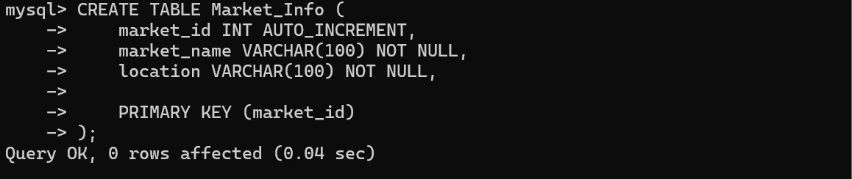

Question-2:
Create a table named Farmer_Info with the following fields
name should NOT accept NULL values
phone should NOT accept NULL values
village can be NULL
SQL Statement:
CREATE TABLE Farmer_Info (
farmer_id INT AUTO_INCREMENT,
name VARCHAR(100) NOT NULL,
phone VARCHAR(15) NOT NULL,
village VARCHAR(100),
PRIMARY KEY (farmer_id)
);
Output:
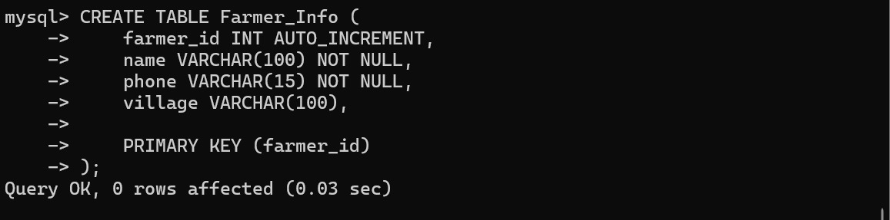
Question 3 :
Modify the Farmer table to ensure that the aadhar number is unique for every farmer.
SQL Statement:
ALTER TABLE Farmer
ADD CONSTRAINT unique_aadhar UNIQUE (aadhar);

Output:
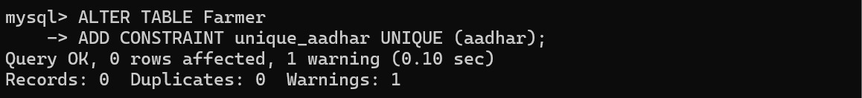
Question 4:
Add a CHECK constraint to ensure Aadhaar must be exactly 12 digits and not less.
SQL Statement:
ALTER TABLE Farmer
ADD CONSTRAINT chk_aadhar_length
CHECK (CHAR_LENGTH(aadhar) = 12);

Output:
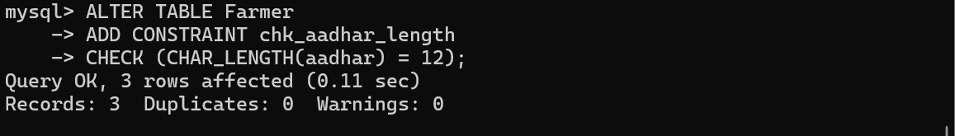

Question 5:
Set default value of district as 'Nalgonda' if not provided.

SQL Statement:
ALTER TABLE Farmer
MODIFY district VARCHAR(50) DEFAULT 'Nalgonda';

Output:
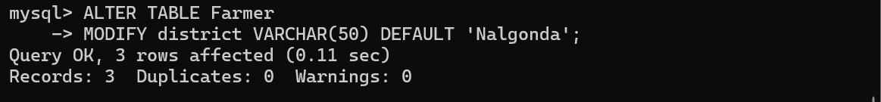

  - Queries based on Aggregate Functions

Question:
Find total number of farmers in the database

SQL Statement:
SELECT COUNT(*) AS total_farmers
FROM Farmer;

Output:
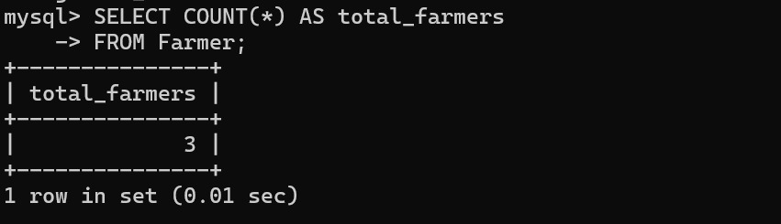

Question:
Find farmers who own more number of land records than the average land count per farmer.

SQL Statement:
SELECT farmer_id, COUNT(*) AS land_count
FROM Land
GROUP BY farmer_id
HAVING COUNT(*) > (
SELECT AVG(cnt)
FROM (
SELECT COUNT(*) AS cnt
FROM Land
GROUP BY farmer_id
) AS temp
);

Output:
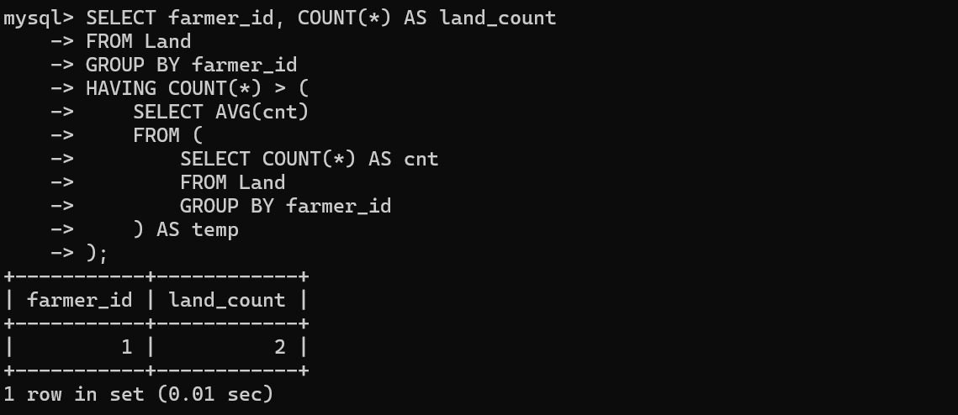

Question:
Find total land area owned by all farmers

SQL Statement:
SELECT SUM(area_acres) AS total_land
FROM Land;

Output:
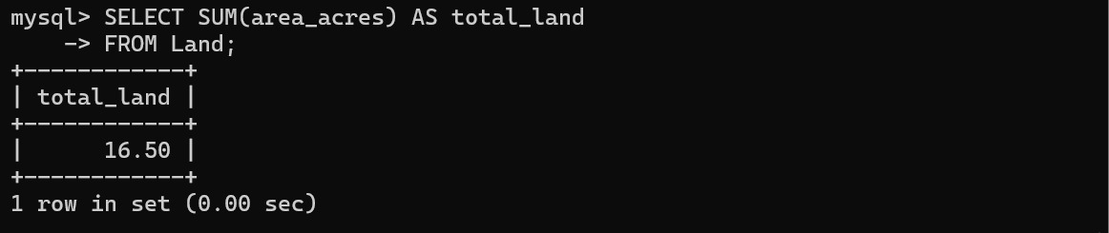

Question:
Find farmers whose total land area is greater than the average total land per farmer.
SQL Statement:

SELECT farmer_id, SUM(area_acres) AS total_land
FROM Land
GROUP BY farmer_id
HAVING SUM(area_acres) > (
SELECT AVG(total_land)
FROM (
SELECT SUM(area_acres) AS total_land
FROM Land
GROUP BY farmer_id
) AS temp
);

Output:
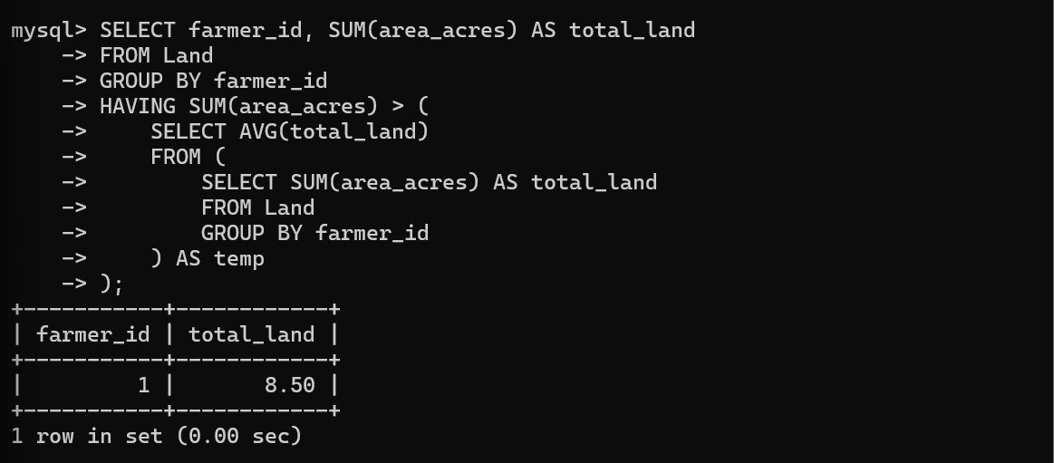

  - Complex queries based on Sets
Question:
Combine farmer districts and crop names into a single list (unique values).

SQL Statement:

SELECT district AS info
FROM Farmer
UNION
SELECT name
FROM Crop;
Output:
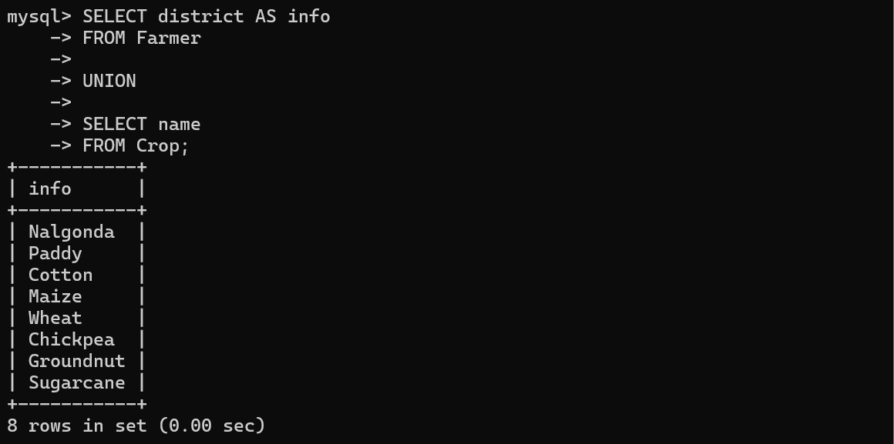
Question:
Combine farmer districts and crop names including duplicates.

SQL Statement:

SELECT district AS info
FROM Farmer
UNION ALL
SELECT name
FROM Crop;

Output:
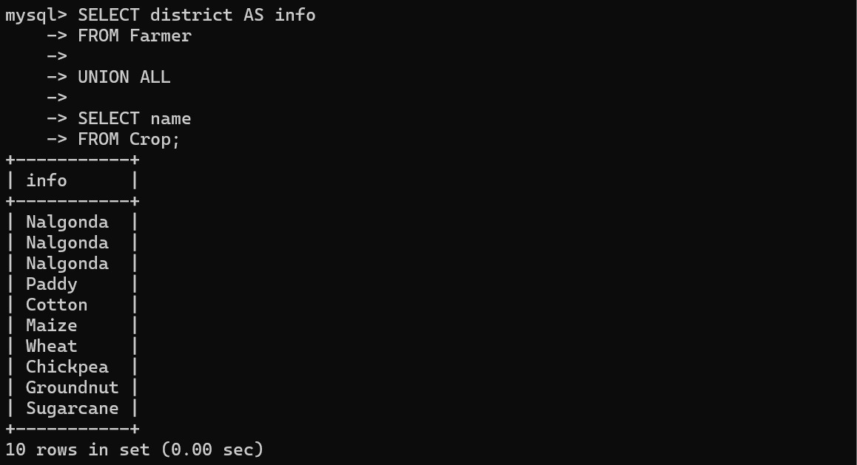

Question:
Find values common in Farmer.district and Crop.name
SQL Statement:

SELECT DISTINCT F.district
FROM Farmer F
INNER JOIN Crop C
ON F.district = C.name;

Output
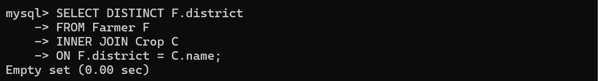

Question:
Find farmer districts that are NOT crop names

SQL Statement:
SELECT DISTINCT district
FROM Farmer
WHERE district NOT IN (
SELECT name FROM Crop
);
Output:
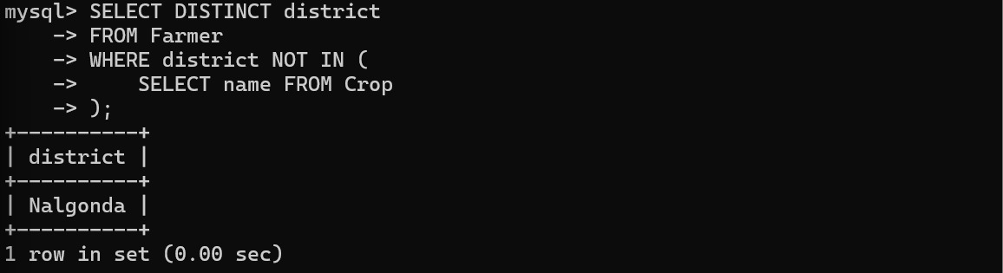

  - Complex queries based on Subqueries

Question:
Find farmers and crops where season is 'rabi

SQL Statement:
SELECT F.id, F.village, C.name
FROM Farmer F
JOIN Crop C ON C.season = 'rabi';

Output:
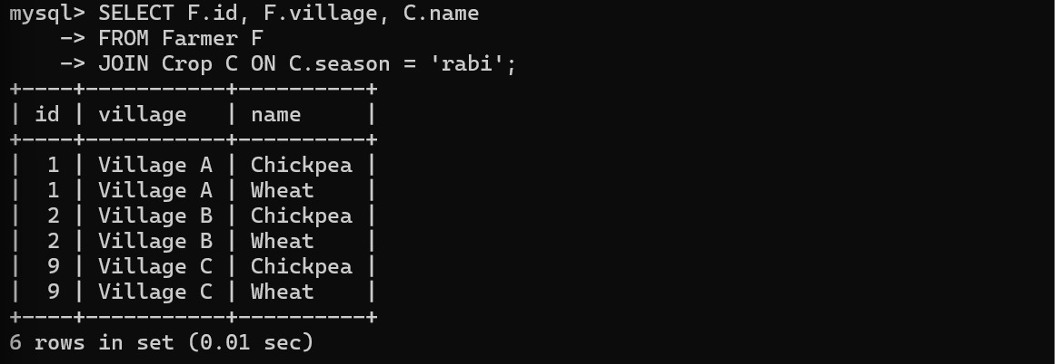

Question:
Find farmers matched with crops having high duration
SQL Statement:
SELECT F.id, C.name, C.duration_days
FROM Farmer F
JOIN Crop C ON C.duration_days > 120;

Output:
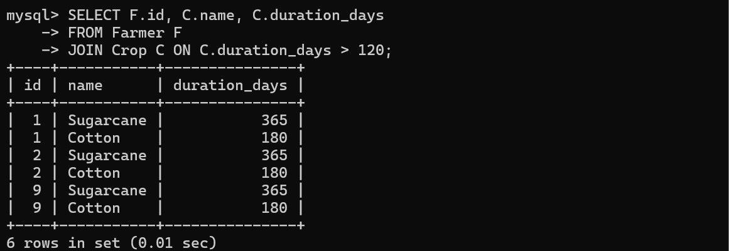
Question:
Find crops with duration less than 110 days
SQL Statement:
SELECT name, duration_days
FROM Crop
WHERE duration_days < 110;

Output:
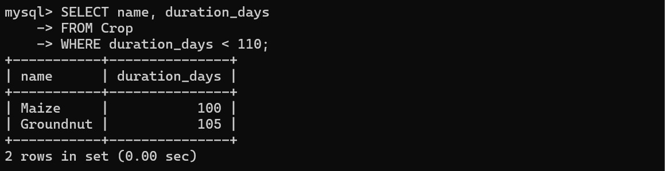
Question:
Find crops where duration > 100 AND temperature < 35
SQL Statement:
SELECT name, duration_days, max_temp_c
FROM Crop
WHERE duration_days > 100
AND max_temp_c < 35;

Output:
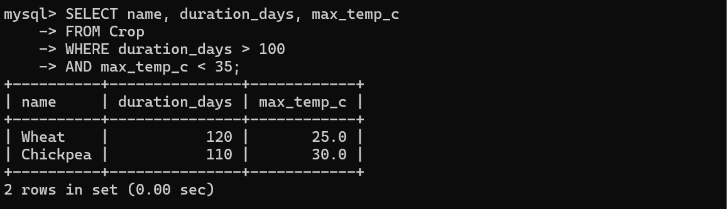

Question:
Find crops whose duration matches any duration in specific crops
SQL Statement:
SELECT name
FROM Crop
WHERE duration_days IN (
SELECT duration_days
FROM Crop
WHERE season = 'kharif'
);

Output:
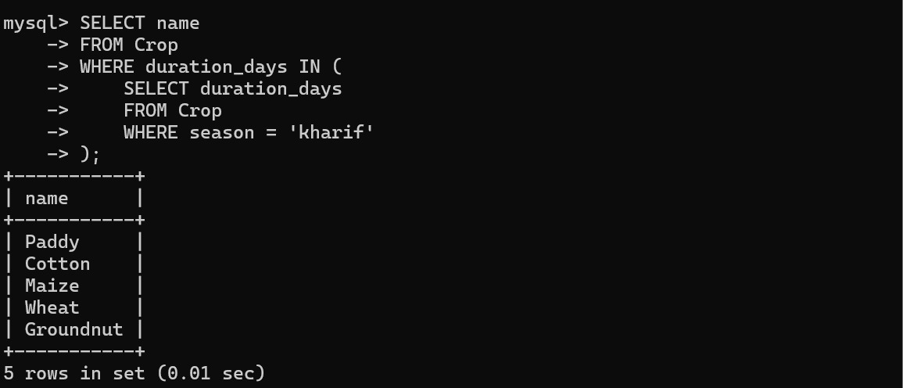
Question:
Find crops whose duration is NOT equal to any rabi crop duration
SQL Statement:
SELECT name
FROM Crop
WHERE duration_days NOT IN (
SELECT duration_days
FROM Crop
WHERE season = 'rabi'
);
Output:
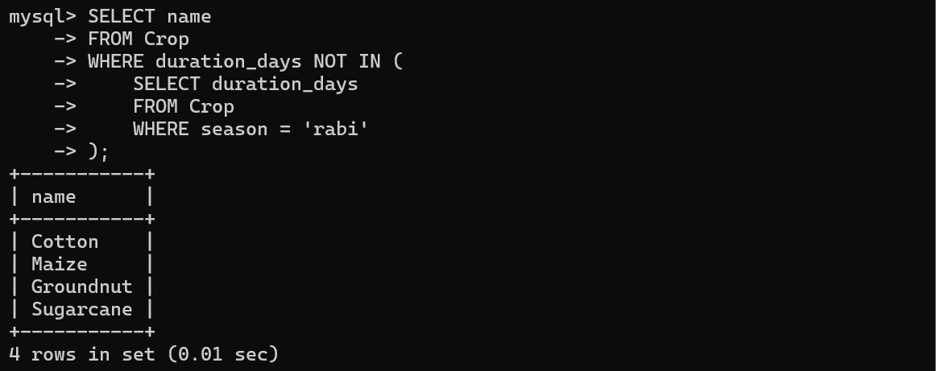
Question:
Find crops with duration greater than ANY kharif crop

SQL Statement:
SELECT name, duration_days
FROM Crop
WHERE duration_days > ANY (
SELECT duration_days
FROM Crop
WHERE season = 'kharif'
);
Output:
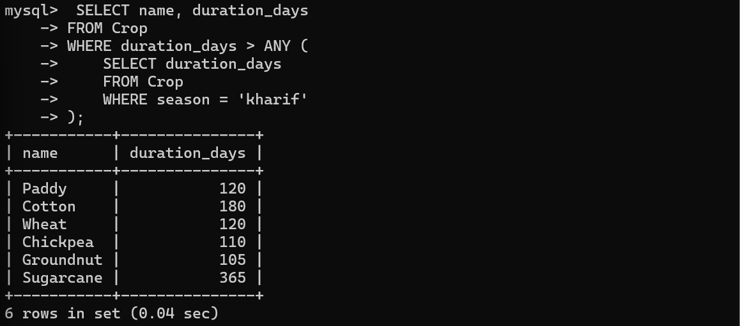

Question:
Get farmers who have registered at least one piece of land.
SQL Statement:
SELECT * FROM farmer f
WHERE EXISTS (
SELECT 1
FROM land l
WHERE l.farmer_id = f.id
);
Output:
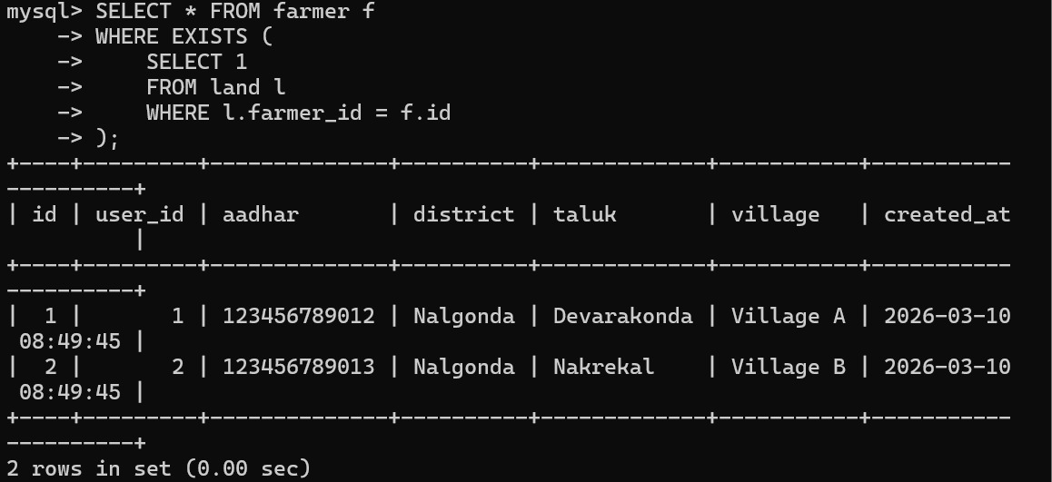
Question:
Find farmers who do NOT have any soil reports.
SQL Statement:
SELECT id, aadhar, taluk
FROM farmer f
WHERE NOT EXISTS (
SELECT 1
FROM soil_report sr
JOIN land l ON sr.land_id = l.id
WHERE l.farmer_id = f.id
);

Output:
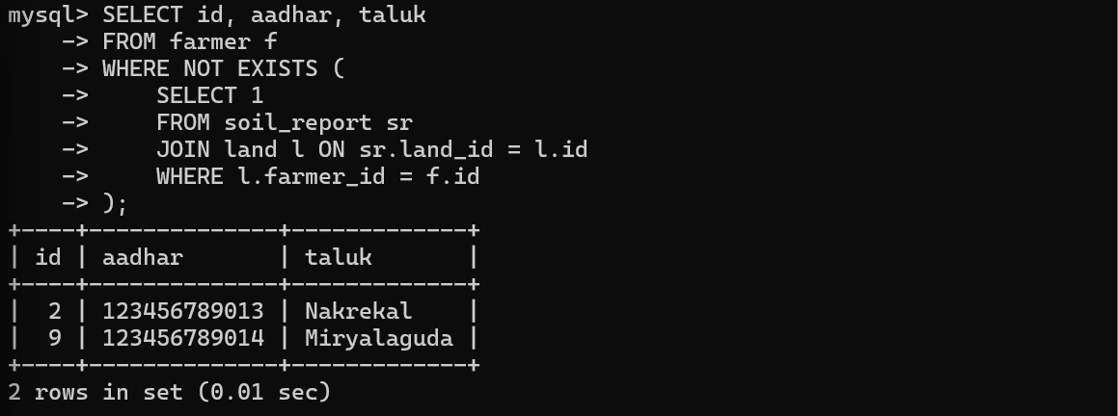

  - Complex queries based on Joins
Question:
View all land plots alongside their pH and Nitrogen levels.
SQL Statement:
SELECT
l.survey_no,
l.soil_type,
l.irrigation_type,
sr.ph,
sr.nitrogen_ppm,
sr.recommendations
FROM land l
INNER JOIN soil_report sr ON l.id = sr.land_id;
Output:
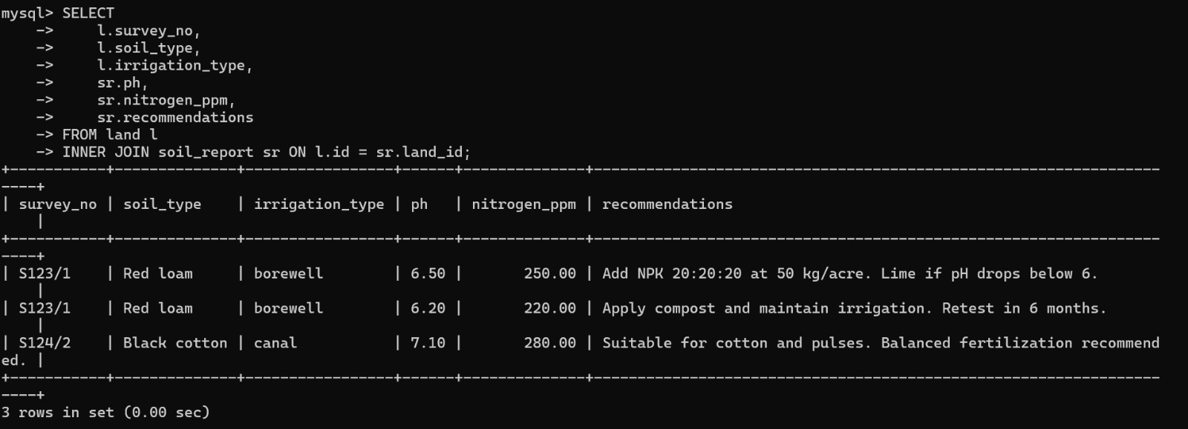

Question:
Find all farmers and their land details, including farmers who haven't registered any land yet.
SQL Statement:
SELECT
f.id AS farmer_id,
f.village,
l.survey_no,
l.area_acres
FROM farmer f
LEFT JOIN land l ON f.id = l.farmer_id;
Output:
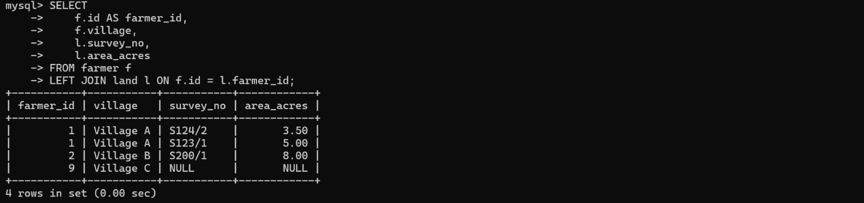

Question:
Find all soil reports and the land they belong to. If a report exists that somehow isn't linked to a valid land ID, the land details will be NULL.

SQL Statement:
SQL
SELECT
l.survey_no,
sr.report_date,
sr.ph
FROM land l
RIGHT JOIN soil_report sr ON l.id = sr.land_id;

Output:
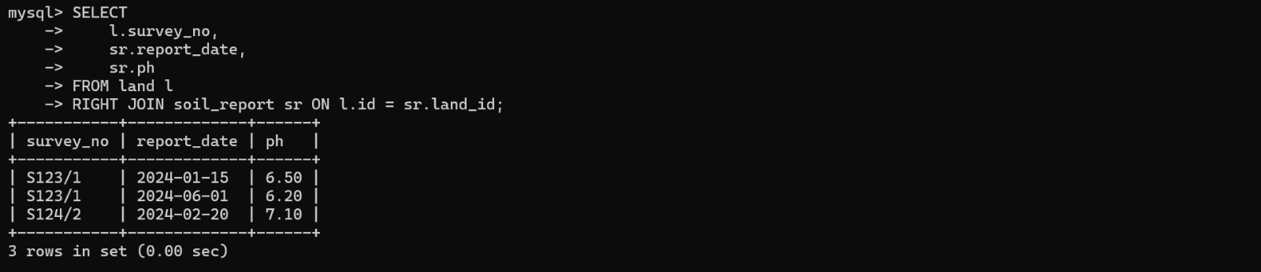

  - Complex queries based on views
Question:
Create a view named Farmer_Crop_Dashboard that shows farmer details alongside suitable crops based on seasons.
SQL Statement:
CREATE VIEW Farmer_Crop_Dashboard AS
SELECT
f.id AS farmer_id,
f.village,
f.district,
c.name AS crop_name,
c.season,
CASE
WHEN c.water_requirement = 'high' THEN 'Requires Heavy Irrigation'
ELSE 'Normal Irrigation'
END AS water_advice
FROM farmer f
JOIN crop c ON c.season = 'kharif' OR c.season = 'all';
Output:
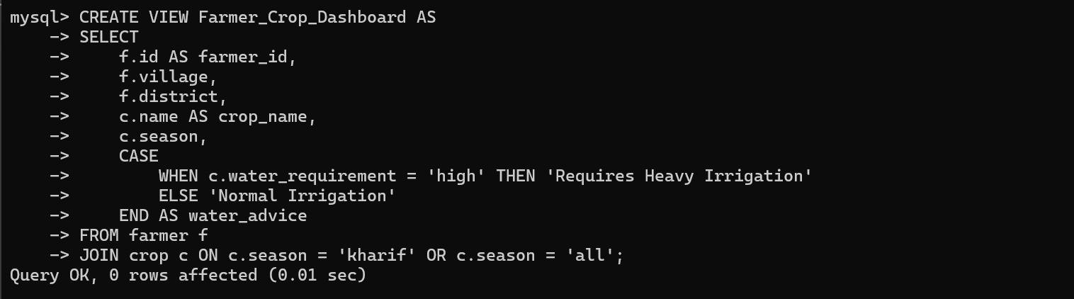

Question:
Retrieve all "High Irrigation" crop plans from the dashboard for 'Village A'.
SQL Statement:
SELECT * FROM Farmer_Crop_Dashboard
WHERE village = 'Village A'
AND water_advice = 'Requires Heavy Irrigation';

Output:
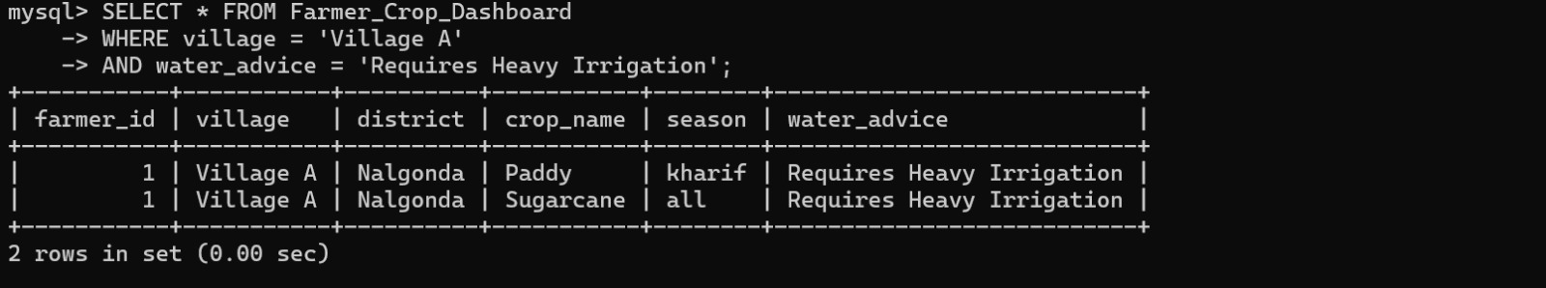

Question:
Update the dashboard to include the crop duration days.

SQL Statement:
CREATE OR REPLACE VIEW Farmer_Crop_Dashboard AS
SELECT
f.id AS farmer_id,
f.village,
c.name AS crop_name,
c.duration_days, -- Added new column
c.season
FROM farmer f
JOIN crop c ON c.season = 'kharif' OR c.season = 'all';

Output:
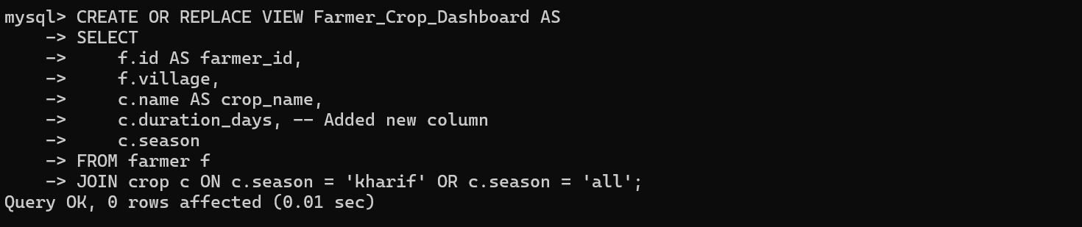
Question:
Remove the dashboard view from the system
SQL Statement:
DROP VIEW Farmer_Crop_Dashboard;

Output:
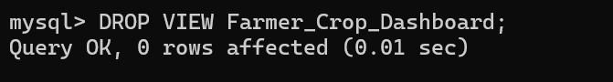

  - Complex queries based on Triggers
Question:
This trigger prevents a soil_report from being saved if the pH value is unrealistic (outside the 0–14 range).

SQL Statement:
DELIMITER //

CREATE TRIGGER validate_soil_ph
BEFORE INSERT ON soil_report
FOR EACH ROW
BEGIN
IF NEW.ph < 0 OR NEW.ph > 14 THEN
SIGNAL SQLSTATE '45000'
SET MESSAGE_TEXT = 'Invalid pH value. Must be between 0 and 14.';
END IF;
END //

DELIMITER ;

Output:
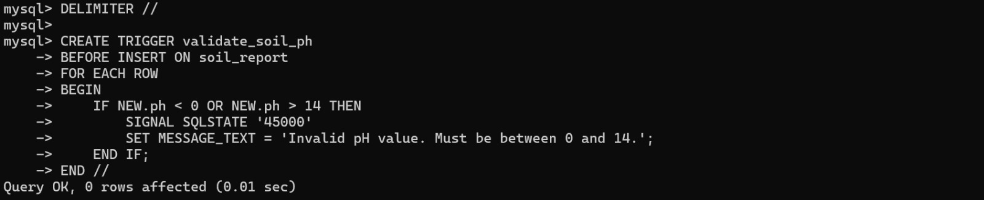
Question:
Create a trigger that automatically logs every new farmer registration into a log table.

SQL Statement:
CREATE TABLE farmer_log (
log_id INT AUTO_INCREMENT PRIMARY KEY,
farmer_id INT,
aadhar VARCHAR(12),
action VARCHAR(50),
log_time DATETIME DEFAULT CURRENT_TIMESTAMP
);

DELIMITER //
CREATE TRIGGER trg_after_farmer_insert
AFTER INSERT ON farmer
FOR EACH ROW
BEGIN
INSERT INTO farmer_log (farmer_id, aadhar, action)
VALUES (NEW.id, NEW.aadhar, 'NEW FARMER REGISTERED');
END;
//
DELIMITER ;
-- Test
INSERT INTO farmer (user_id, aadhar, district, taluk, village, created_at)
VALUES (4, '987654321012', 'Nalgonda', 'Devarakonda', 'Village D', NOW());
SELECT * FROM farmer_log;

Output:
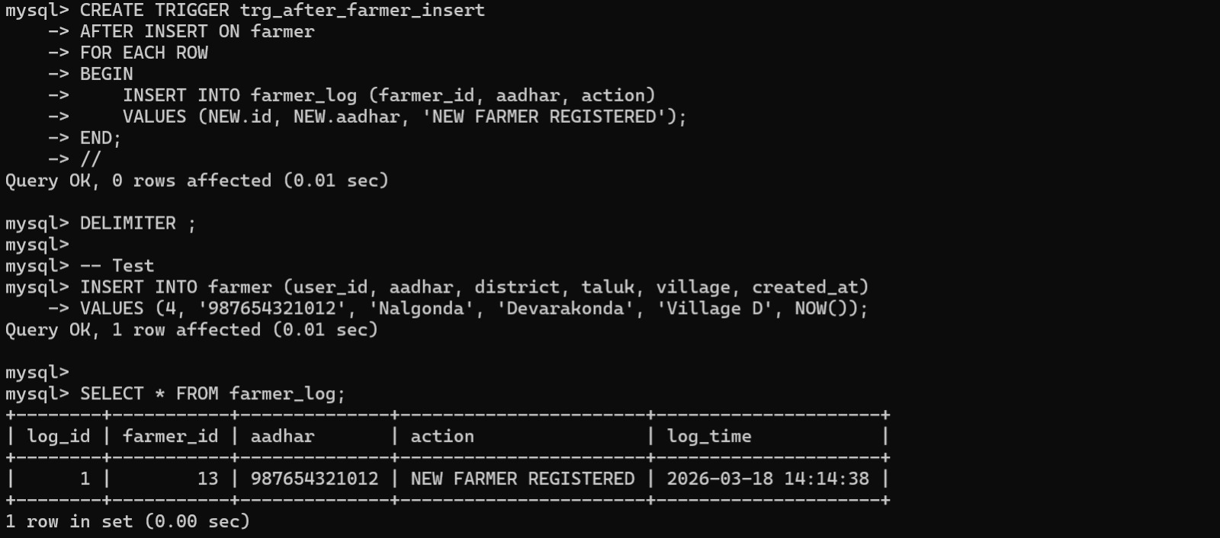

  - Complex queries based on Cursors
Question:
Create a cursor that prints the survey number and soil type of all land plots with an area greater than 5.0 acres.
SQL Statement:
DELIMITER //
CREATE PROCEDURE proc_large_land_plots()
BEGIN
DECLARE v_survey VARCHAR(50);
DECLARE v_soil VARCHAR(50);
DECLARE v_area DECIMAL(10,2);
DECLARE done INT DEFAULT 0;

DECLARE cur CURSOR FOR
SELECT survey_no, soil_type, area_acres
FROM land
WHERE area_acres > 5.0;

DECLARE CONTINUE HANDLER FOR NOT FOUND SET done = 1;

OPEN cur;
read_loop: LOOP
FETCH cur INTO v_survey, v_soil, v_area;
IF done = 1 THEN
LEAVE read_loop;
END IF;
SELECT v_survey AS SurveyNumber, v_soil AS SoilType, v_area AS TotalAcres;
END LOOP;
CLOSE cur;
END;
//
DELIMITER ;
CALL proc_large_land_plots();

Output:
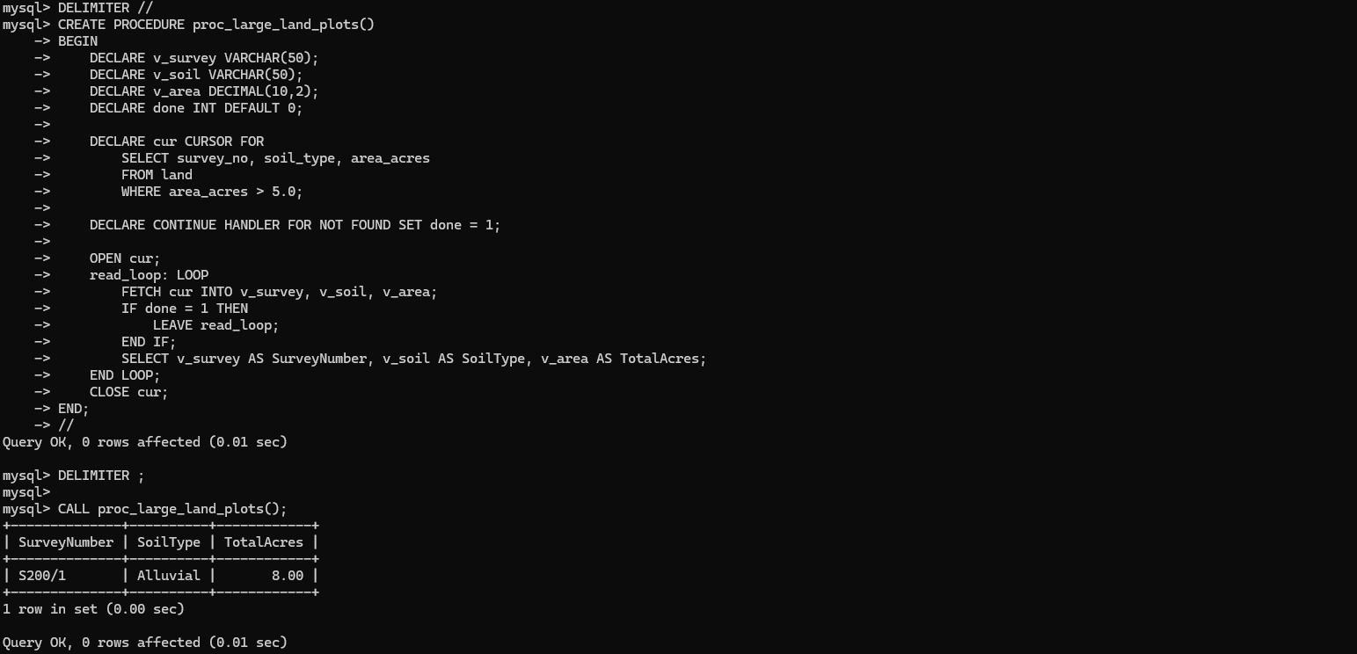
Question:
Create a cursor that loops through all crops and prints those with high water requirements and a duration longer than 100 days

SQL Statement:
DELIMITER //
CREATE PROCEDURE proc_water_intensive_crops()
BEGIN
DECLARE v_crop_name VARCHAR(100);
DECLARE v_days INT;
DECLARE done INT DEFAULT 0;
DECLARE cur CURSOR FOR
SELECT name, duration_days
FROM crop
WHERE water_requirement = 'high' AND duration_days > 100;
DECLARE CONTINUE HANDLER FOR NOT FOUND SET done = 1;

OPEN cur;
read_loop: LOOP
FETCH cur INTO v_crop_name, v_days;
IF done = 1 THEN
LEAVE read_loop;
END IF;
SELECT v_crop_name AS CropName, v_days AS GrowthDuration;
END LOOP;
CLOSE cur;
END;
//
DELIMITER ;
CALL proc_water_intensive_crops();

Output:
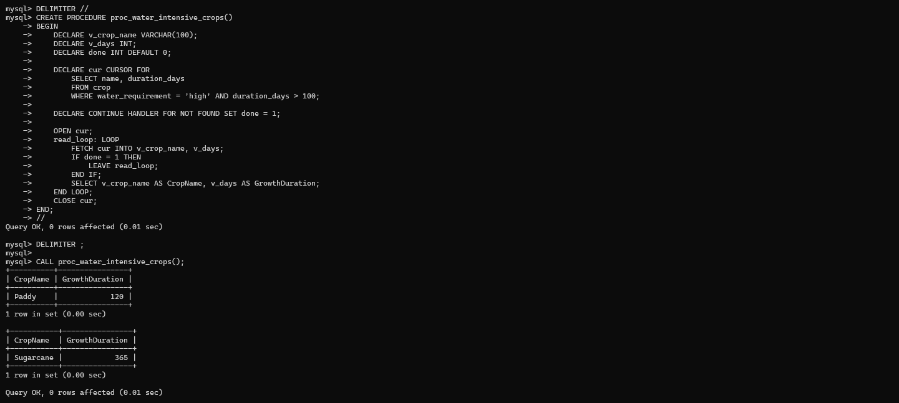

Question:
Create a cursor that loops through all soil reports and prints the survey number and pH level for acidic soils (pH < 6.5).
SQL Statement:
DELIMITER //
CREATE PROCEDURE proc_acidic_soil_report()
BEGIN
DECLARE v_survey VARCHAR(50);
DECLARE v_ph DECIMAL(3,2);
DECLARE done INT DEFAULT 0;

DECLARE cur CURSOR FOR
SELECT l.survey_no, sr.ph
FROM land l
JOIN soil_report sr ON l.id = sr.land_id
WHERE sr.ph < 6.5;

DECLARE CONTINUE HANDLER FOR NOT FOUND SET done = 1;

OPEN cur;
read_loop: LOOP
FETCH cur INTO v_survey, v_ph;
IF done = 1 THEN
LEAVE read_loop;
END IF;
SELECT v_survey AS SurveyNo, v_ph AS pH_Level;
END LOOP;
CLOSE cur;
END;
//
DELIMITER ;
CALL proc_acidic_soil_report();

Output:
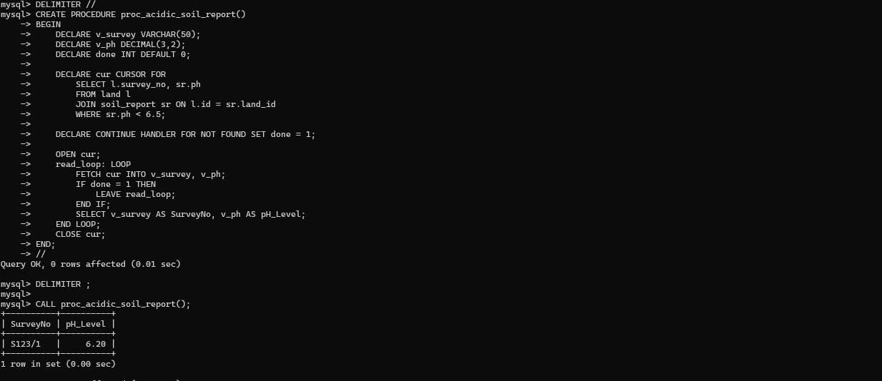

CHAPTER 4

ANALYZING THE PITFALLS, IDENTIFYING THE DEPENDENCIES, AND APPLYING NORMALIZATIONS
Unnormalized Table
CREATE TABLE unnormalized_agriculture (
farmer_id INT,
farmer_name VARCHAR(100),
village VARCHAR(100),
crop_names VARCHAR(255),
fertilizer_names VARCHAR(255),
pest_names VARCHAR(255),
market_names VARCHAR(255),
prices VARCHAR(100)
);
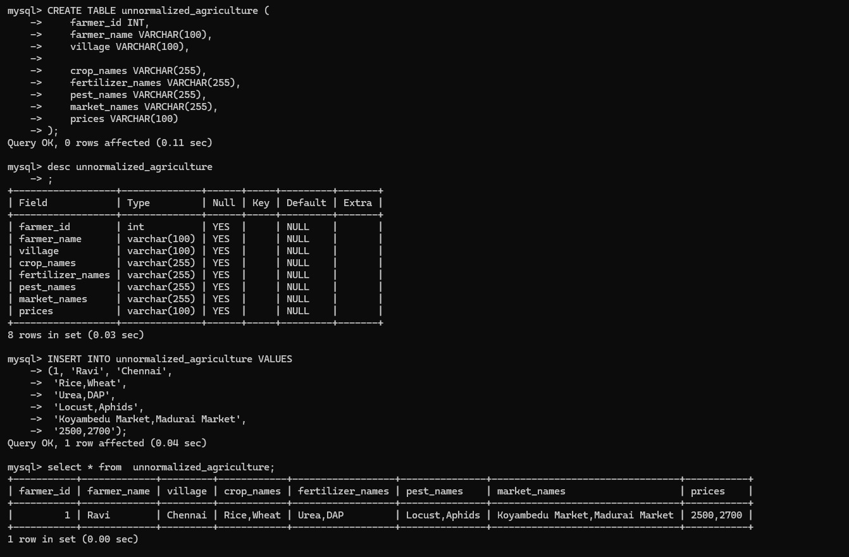
4.1 Analyse the Pitfalls in Relations
1. Repeating Groups
  - Multiple crops, fertilizers, pests in one column
2.Data Redundancy
  - Farmer details repeated for every data
3.Insertion Anomaly
  - Cannot insert crop without farmer
4.Update Anomaly
  - Updating crop/fertilizer is difficult (string editing)
5.Deletion Anomaly
  - Deleting one value removes full row

4.2 First Normal Form
4.2.1: Identify Dependency
Functional Dependencies:
farmer_id → farmer_name, village
crop_name → fertilizer_name
Problem:
  - Multi-valued attributes
  - Not atomic
Rule :
  - Each column must contain atomic (single) values
  - No repeating groups

4.2.2: Apply Normalization to 1NF
Create 1NF Table
CREATE TABLE agriculture_1nf (
farmer_id INT,
farmer_name VARCHAR(100),
village VARCHAR(100),
crop_name VARCHAR(100),
fertilizer_name VARCHAR(100),
pest_name VARCHAR(100),
market_name VARCHAR(100),
price INT
);
Insert Normalized Data
INSERT INTO agriculture_1nf VALUES
(1, 'Ravi', 'Chennai', 'Rice', 'Urea', 'Locust', 'Koyambedu Market', 2500),
(1, 'Ravi', 'Chennai', 'Wheat', 'DAP', 'Aphids', 'Madurai Market', 2700);

1NF TABLE:
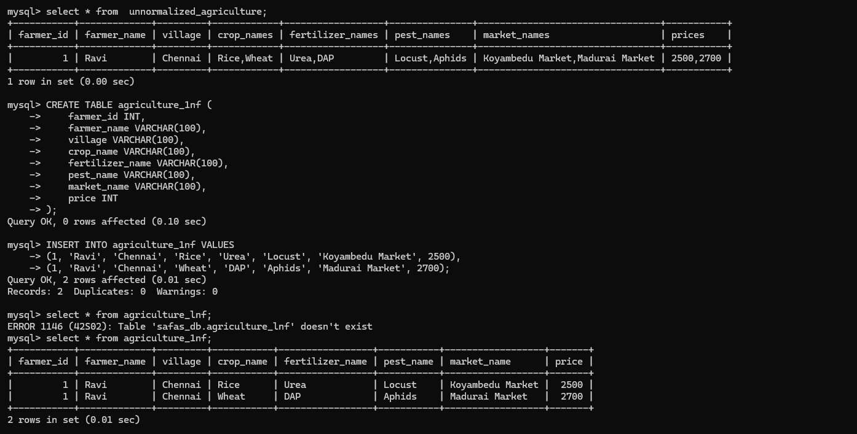

4.3 Second Normal Form
4.3.1: Identify Dependency
Partial Dependency
- farmer_name depends only on farmer_id
- village depends only on farmer_id
- fertilizer depends only on crop
problem:
  - farmer_name depends only on farmer_id
  - fertilizer & pest depend only on crop
  - Not dependent on full primary key
Rule:
Remove partial dependency
Non-key attributes must depend on FULL primary key
4.3.2: Apply Normalization to 2NF

Create Farmer Table
CREATE TABLE farmer_2nf (
farmer_id INT PRIMARY KEY,
farmer_name VARCHAR(100),
village VARCHAR(100)
);
Create Crop Table
CREATE TABLE crop_2nf (
crop_id INT AUTO_INCREMENT PRIMARY KEY,
crop_name VARCHAR(100),
fertilizer_name VARCHAR(100)
);
Create Farmer-Crop Table
CREATE TABLE farmer_crop_2nf (
farmer_id INT,
crop_id INT,
PRIMARY KEY (farmer_id, crop_id),
FOREIGN KEY (farmer_id) REFERENCES farmer_2nf(farmer_id),
FOREIGN KEY (crop_id) REFERENCES crop_2nf(crop_id)
);
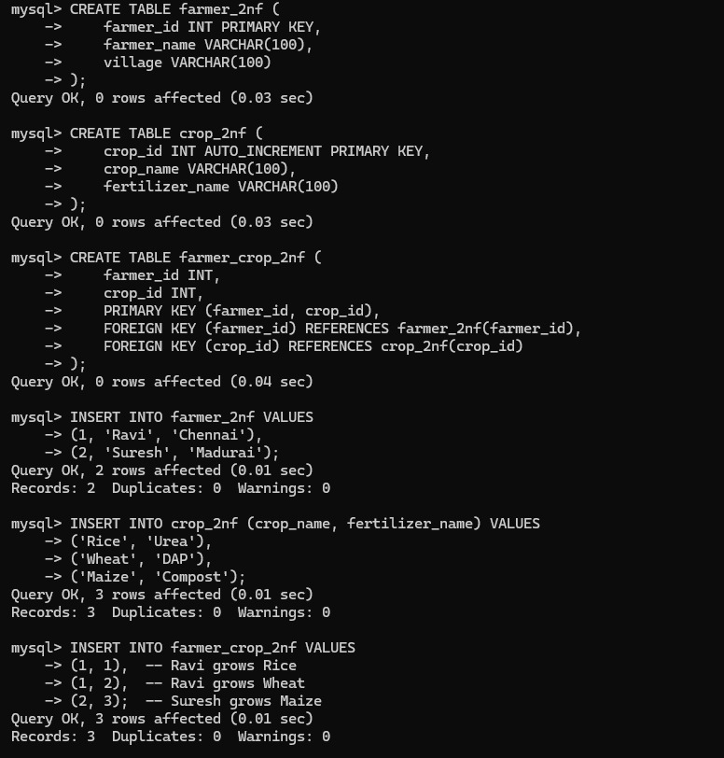

Insert Data
Farmer :
INSERT INTO farmer_2nf VALUES
(1, 'Ravi', 'Chennai'),
(2, 'Suresh', 'Madurai');
Crop Table
INSERT INTO crop_2nf (crop_name, fertilizer_name) VALUES
('Rice', 'Urea'),
('Wheat', 'DAP'),
('Maize', 'Compost');

Farmer-Crop Table
INSERT INTO farmer_crop_2nf VALUES
(1, 1), -- Ravi grows Rice
(1, 2), -- Ravi grows Wheat
(2, 3); -- Suresh grows Maize

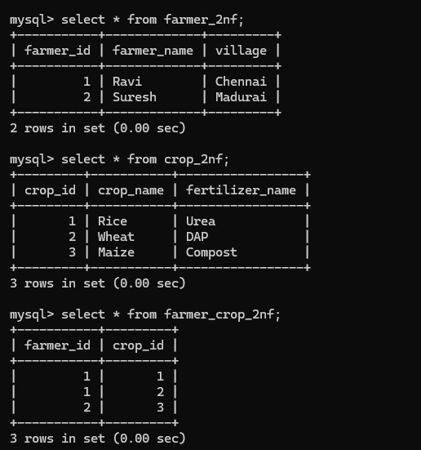

4.4 Third Normal Form
4.4.1: Identify Dependency
Functional Dependencies
farmer_id → village
village → district
market_name → price

Transitive Dependency:
farmer_id → village → district
district indirectly depends on farmer_id
Rule:
No transitive dependency
Non-key attributes should depend only on primary key
4.4.2: Apply Normalization to 3NF
Create Farmer Table
CREATE TABLE farmer_3nf (
farmer_id INT PRIMARY KEY,
farmer_name VARCHAR(100)
);
Create Location Table
CREATE TABLE location_3nf (
location_id INT PRIMARY KEY,
village VARCHAR(100)
);
Create Crop Table
CREATE TABLE crop_3nf (
crop_id INT PRIMARY KEY,
crop_name VARCHAR(100)
);
Create Fertilizer Table
CREATE TABLE fertilizer_3nf (
fertilizer_id INT PRIMARY KEY,
fertilizer_name VARCHAR(100)
);
Create Crop Fertilizer Table
CREATE TABLE crop_fertilizer_3nf (
crop_id INT,
fertilizer_id INT
);

Insert Data

Crop Table
INSERT INTO crop_3nf VALUES
(201, 'Rice'),
(202, 'Wheat'),
(203, 'Maize');
Fertilizer Table
INSERT INTO fertilizer_3nf VALUES
(301, 'Urea'),
(302, 'DAP'),
(303, 'Compost');
Crop-Fertilizer Table
INSERT INTO crop_fertilizer_3nf VALUES
(201, 301), -- Rice → Urea
(202, 302), -- Wheat → DAP
(203, 303); -- Maize → Compost
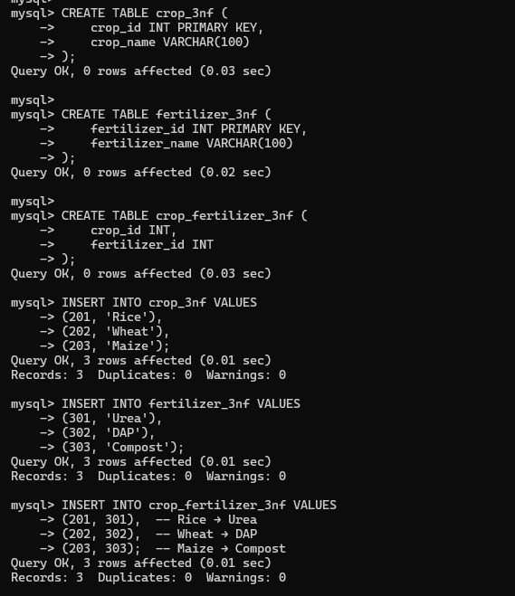

Insert Data
1. Fertilizer Table (BCNF)
INSERT INTO fertilizer_bcnf VALUES
(301, 'Urea'),
(302, 'DAP'),
(303, 'Compost');
2. Crop Table (BCNF)
INSERT INTO crop_bcnf VALUES
(201, 'Rice'),
(202, 'Wheat'),
(203, 'Maize');
3. Crop-Fertilizer Table (BCNF)
INSERT INTO crop_fertilizer_bcnf VALUES
(201, 301), -- Rice → Urea
(202, 302), -- Wheat → DAP
(203, 303); -- Maize → Compost
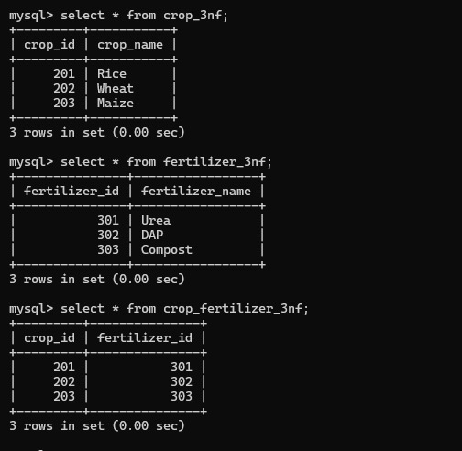

4.5 BCNF
4.5.1: Identify Dependency
Functional Dependey:
crop_name → fertilizer_name
Problem:
crop_name determines fertilizer
But crop_name is not a candidate key
Rule (BCNF):
Every determinant must be a candidate key
4.5.2: Apply Normalization to BCNF
Create Medicine Table
CREATE TABLE fertilizer_bcnf (
Fertilizer_id INT PRIMARY KEY,
fertilizer_name VARCHAR(100)
);

Create Crop Table
CREATE TABLE crop_bcnf (
crop_id INT PRIMARY KEY,
crop_name VARCHAR(100)
);
Create Crop Fertilizer Table
CREATE TABLE crop_fertilizer_bcnf (
crop_id INT,
fertilizer_id INT,
PRIMARY KEY (crop_id, fertilizer_id)
);
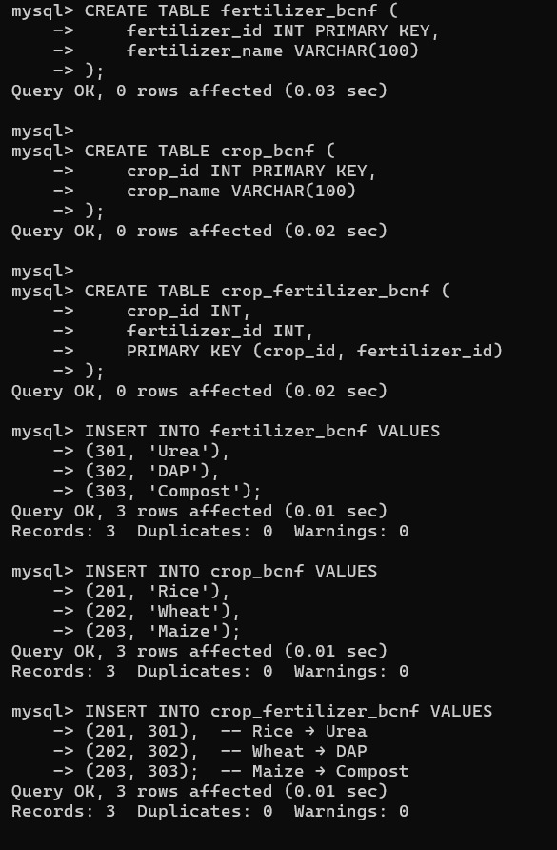

Insert Data
1. Fertilizer Table (BCNF)
INSERT INTO fertilizer_bcnf VALUES
(301, 'Urea'),
(302, 'DAP'),
(303, 'Compost');
2. Crop Table (BCNF)
INSERT INTO crop_bcnf VALUES
(201, 'Rice'),
(202, 'Wheat'),
(203, 'Maize');
3. Crop-Fertilizer Table (BCNF)
INSERT INTO crop_fertilizer_bcnf VALUES
(201, 301), -- Rice → Urea
(202, 302), -- Wheat → DAP
(203, 303); -- Maize → Compost
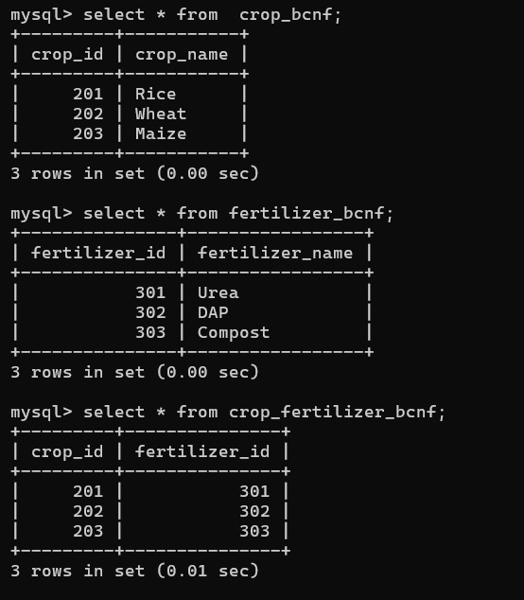
4.6 Fourth Normal Form
4.6.1: Identify Dependency
Multivalued Dependency:
crop_name →→ pest_name
crop_name →→ market_name
Problem:
One crop has multiple pests
One crop has multiple markets
Independent multi-valued attributes
Rule:
No multivalued dependency
Separate independent multi-valued attributes
4.6.2: Apply Normalization to 4NF
Create Crop Table
CREATE TABLE crop_pest_4nf (
crop_id INT,
pest_name VARCHAR(100)
);
Create Crop Market Table
CREATE TABLE crop_market_4nf (
crop_id INT,
market_name VARCHAR(100)

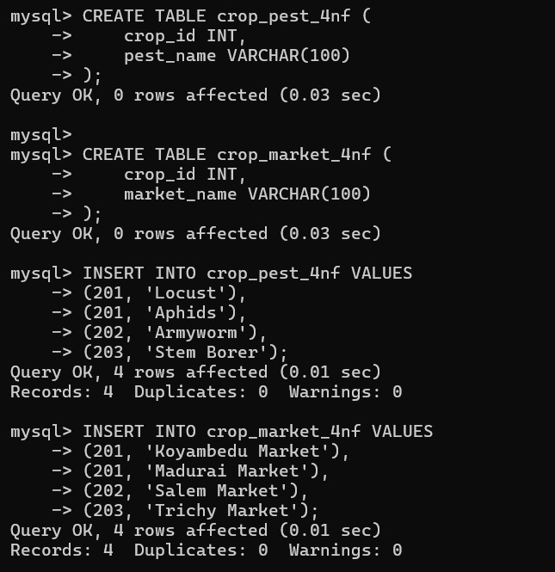
Insert Data
1. Crop–Pest Table
INSERT INTO crop_pest_4nf VALUES
(201, 'Locust'),
(201, 'Aphids'),
(202, 'Armyworm'),
(203, 'Stem Borer');
2. Crop–Market Table
INSERT INTO crop_market_4nf VALUES
(201, 'Koyambedu Market'),
(201, 'Madurai Market'),
(202, 'Salem Market'),
(203, 'Trichy Market');

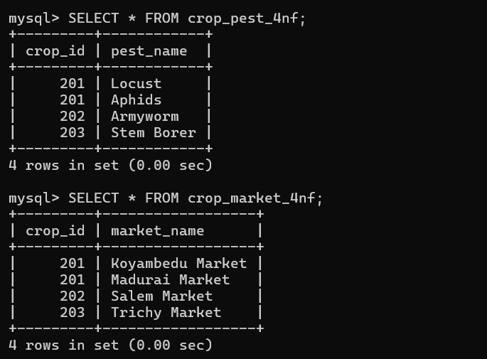

4.7 Fifth Normal Form
4.7.1: Identify Dependency
Join Dependency:
(farmer_id, crop_name, market_name)

Problem:
Data can be split into smaller relations
Redundant combinations exist
Complex joins required

Rule:
Decompose tables to remove join dependency
Ensure lossless join

4.7.2: Apply Normalization to 5NF
Create Farmer Crop Table
CREATE TABLE farmer_crop_5nf (
farmer_id INT,
crop_id INT,
PRIMARY KEY (farmer_id, crop_id)
);

Create Crop Market Table
CREATE TABLE crop_market_5nf (
crop_id INT,
market_name VARCHAR(100),
PRIMARY KEY (crop_id, market_name)
);
Create Farmer Market Table
CREATE TABLE farmer_market_5nf (
farmer_id INT,
market_name VARCHAR(100),
PRIMARY KEY (farmer_id, market_name)
);

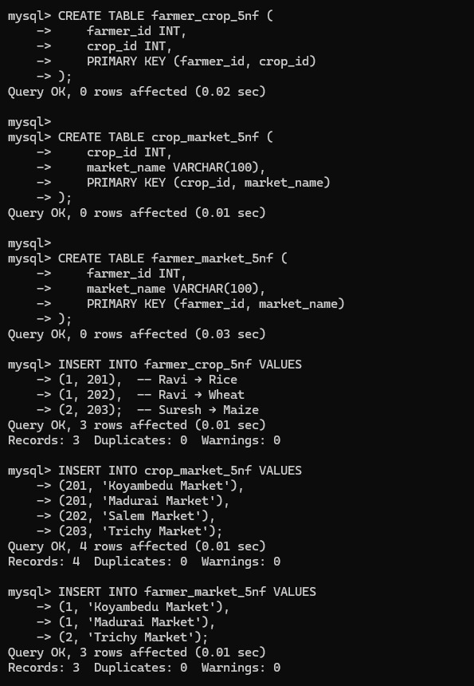

Insert Table
1. Farmer–Crop Table
INSERT INTO farmer_crop_5nf VALUES
(1, 201), -- Ravi → Rice
(1, 202), -- Ravi → Wheat
(2, 203); -- Suresh → Maize
2.Crop–Market Table
INSERT INTO crop_market_5nf VALUES
(201, 'Koyambedu Market'),
(201, 'Madurai Market'),
(202, 'Salem Market'),
(203, 'Trichy Market');
3. Farmer–Market Table
INSERT INTO farmer_market_5nf VALUES
(1, 'Koyambedu Market'),
(1, 'Madurai Market'),
(2, 'Trichy Market');

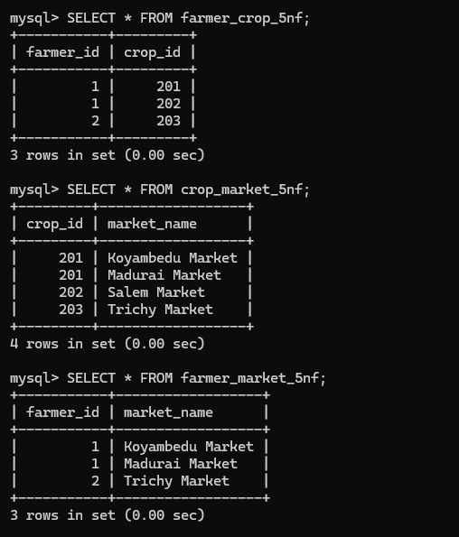
CHAPTER 5
IMPLEMENTATION OF CONCURRENCY CONTROL AND RECOVERY MECHANISMS

5.1 Introduction to Transactions

A transaction is a sequence of one or more SQL operations executed as a single logical unit of work. It ensures that database operations are performed reliably and consistently.
In the Smart Agriculture & Farmer Assistance System (SAFAS), transactions are used to maintain accuracy while performing operations such as updating farmer details, inserting crop plans, managing fertilizer recommendations, recording sales, and handling subsidies.
A transaction must follow certain rules to maintain database integrity, known as ACID properties.

5.1.1 Properties
1. Atomicity
Atomicity ensures that a transaction is treated as a single unit.
Either all operations are executed successfully, or none are applied.
Example:
If updating a farmer’s crop plan fails midway, all previous changes are rolled back.
2. Consistency
Consistency ensures that the database remains in a valid state before and after the transaction.
Example:
If a crop is assigned to a land, it must exist in the Crop table.
3. Isolation
Isolation ensures that multiple transactions do not interfere with each other.
Example:
Two users updating the same farmer record simultaneously will not cause conflicts.
4. Durability
Durability ensures that once a transaction is committed, the changes are permanently stored.

Example:
Once a sale record is saved, it will not be lost even if the system crashes.

5.1.2 States
A transaction goes through different states:

1.Active State
Transaction is executing (INSERT, UPDATE).
2.Partially Committed State
All operations completed but not yet saved.
3.Committed State
Changes are permanently stored.
4.Failed State
Error occurs, transaction stops.
5.Aborted State
Transaction is rolled back.
6.Terminated State
Transaction ends after commit/rollback.
Conclusion
Transactions ensure reliable and consistent operations using ACID properties and proper execution states.

5.2 Transaction Control Language (TCL)

Transaction Control Language (TCL) consists of commands that are used to manage and control transactions in a database. These commands ensure that database operations are executed in a controlled and reliable manner, maintaining data integrity and consistency.
In the Smart Agriculture & Farmer Assistance System (SAFAS), TCL commands are essential for handling operations such as updating farmer records, modifying crop plans, managing fertilizer recommendations, recording sales, and handling subsidies without causing inconsistencies.
TCL allows users to:
Save intermediate states of a transaction
Permanently store changes
Undo unwanted or incorrect operations

The main TCL commands include:

SAVEPOINT
COMMIT
ROLLBACK
5.2.1 Save point
A SAVEPOINT is used to create checkpoints within a transaction. It allows partial rollback of a transaction instead of undoing the entire transaction
This is useful in SAFAS where multiple operations like updating farmer details, crop plans, and fertilizer data are performed, and only a specific part needs to be undone.
SQL Example:
START TRANSACTION;
UPDATE farmer_3nf
SET farmer_name = 'Ravi Kumar'
WHERE farmer_id = 1;
SAVEPOINT sp1;
Explanation:
A transaction is started
Farmer details are updated
A savepoint named sp1 is created
The system can roll back to this point if needed
5.2.2 Commit
The COMMIT command is used to permanently save all the changes made during a transaction into the database.
Once a transaction is committed, the changes become permanent and cannot be undone using rollback. COMMIT ensures durability of data.
SQL Example:
START TRANSACTION;
UPDATE crop_3nf
SET crop_name = 'Paddy'
WHERE crop_id = 201;

COMMIT;
Explanation:
A transaction is started
Crop details are updated
All changes are saved permanently
5.2.3 Rollback
The ROLLBACK command is used to undo changes made during a transaction. It can also be applied to a specific savepoint instead of the entire transaction.
SQL Example:
START TRANSACTION;
UPDATE fertilizer_3nf
SET fertilizer_name = 'Invalid'
WHERE fertilizer_id = 301;
SAVEPOINT sp1;
ROLLBACK TO sp1;
Explanation:
Transaction starts
Fertilizer data is updated
A savepoint is created
Rollback returns to that savepoint
Incorrect changes are undone
Conclusion
Transaction Control Language commands provide control over database transactions by allowing users to save, commit, or undo changes, ensuring data consistency and reliability in the Smart Agriculture system.

5.3 5 transactions for Smart Agriculture And Farmer Assisantance System
5.3.1 Transaction codes with output

Transaction 1 – Updating Farmer Name
-- Step 1: Start transaction
START TRANSACTION;

-- Step 2: Update farmer name
UPDATE farmer_3nf
SET farmer_name = 'Ravi Kumar'
WHERE farmer_id = 1;

-- Step 3: Savepoint created
SAVEPOINT sp1;

-- Step 4: Incorrect update
UPDATE farmer_3nf
SET farmer_name = 'Wrong Name'
WHERE farmer_id = 1;

-- Step 5: Rollback to savepoint
ROLLBACK TO sp1;

-- Step 6: Commit final changes
COMMIT;
output:
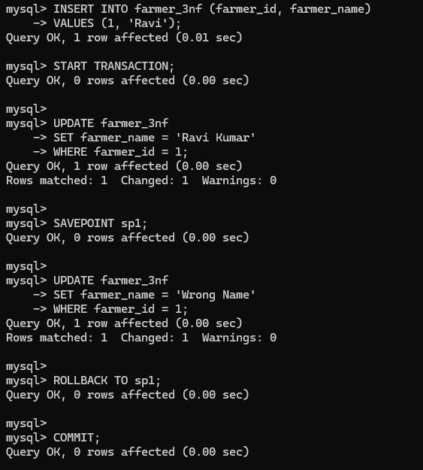

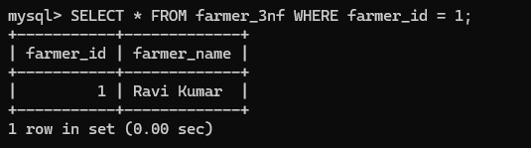

Transaction -2 – Updating CropName
START TRANSACTION;
UPDATE crop_3nf
SET crop_name = 'Paddy'
WHERE crop_id = 201;
SAVEPOINT sp2;
UPDATE crop_3nf
SET crop_name = 'Invalid Crop'
WHERE crop_id = 201;
ROLLBACK TO sp2;
COMMIT;
-- OUTPUT
SELECT * FROM crop_3nf WHERE crop_id = 201;

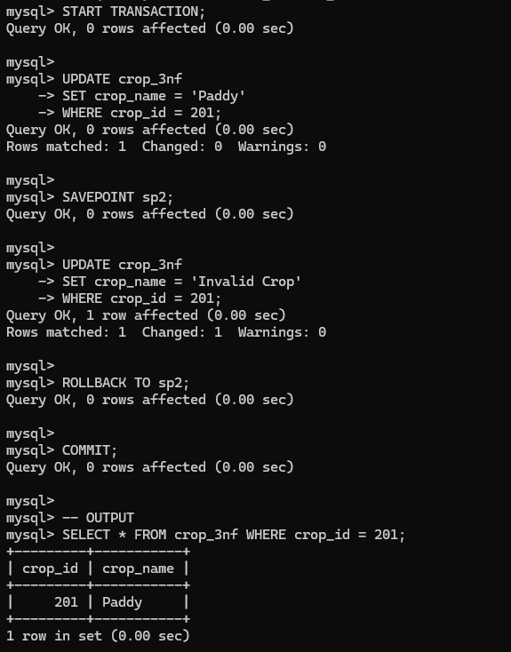

Transaction -3– Insert Sale Record
Step 1: table sale_record
CREATE TABLE sale_record (
sale_id INT PRIMARY KEY,
farmer_id INT,
crop_id INT,
market_id INT,
quantity INT,
total_price INT
);

Step 2: Insert Initial Data
INSERT INTO sale_record VALUES
(1, 1, 201, 101, 10, 25000);

Step 3: Correct Transaction 3
Use NEW sale_id (important)
START TRANSACTION;
-- Correct insert
INSERT INTO sale_record VALUES
(2, 1, 201, 101, 5, 12500);SAVEPOINT sp3;
-- Wrong insert
INSERT INTO sale_record VALUES
(3, 1, 202, 102, 5, 0);
ROLLBACK TO sp3;
COMMIT;
Step 4: Check Output
SELECT * FROM sale_record;
Output:
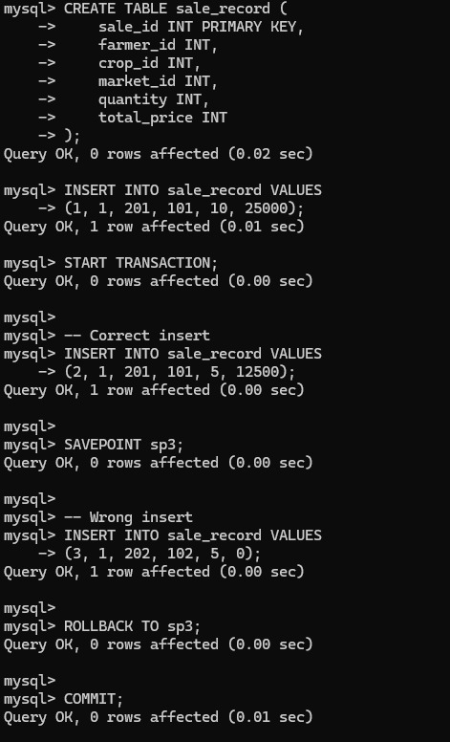

Transaction -4 – Update Fertilizer
STEP 1: Create Table (if not exists)
CREATE TABLE fertilizer_3nf (
fertilizer_id INT PRIMARY KEY,
fertilizer_name VARCHAR(100)
);
STEP 2: Insert Initial Data (VERY IMPORTANT)
INSERT INTO fertilizer_3nf VALUES
(301, 'Urea'),
(302, 'DAP'),
(303, 'Compost');

STEP 3: Transaction 4 (Correct Version)
START TRANSACTION;
-- Step 1: Correct update
UPDATE fertilizer_3nf
SET fertilizer_name = 'Organic Compost'
WHERE fertilizer_id = 303;

-- Step 2: Savepoint
SAVEPOINT sp4;

-- Step 3: Wrong update
UPDATE fertilizer_3nf
SET fertilizer_name = 'Invalid'
WHERE fertilizer_id = 303;

-- Step 4: Rollback
ROLLBACK TO sp4;

-- Step 5: Commit
COMMIT;
STEP 4: Check Output
SELECT * FROM fertilizer_3nf WHERE fertilizer_id = 303;
OUTPUT:
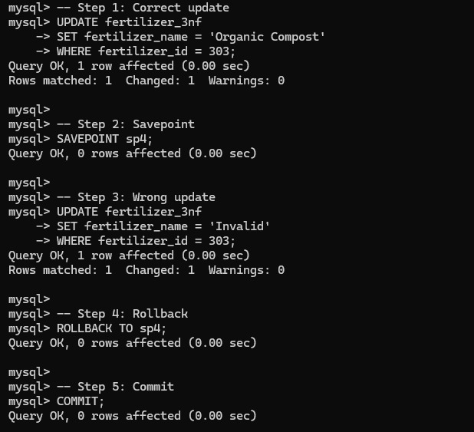

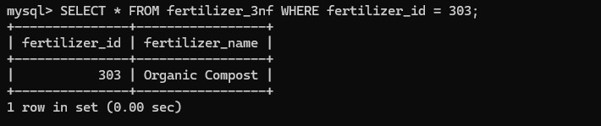

Transaction -5– Delete And Restore Crop
STEP 1: Create Table
CREATE TABLE crop_3nf (
crop_id INT PRIMARY KEY,
crop_name VARCHAR(100)
);
STEP 2: Insert Initial Data
INSERT INTO crop_3nf VALUES
(201, 'Rice'),
(202, 'Wheat'),
(203, 'Maize');

STEP 3: Transaction 5 (Delete & Restore)
START TRANSACTION;
DELETE FROM crop_3nf
WHERE crop_id = 203;
SAVEPOINT sp5;
DELETE FROM crop_3nf
WHERE crop_id = 202;
ROLLBACK TO sp5;
COMMIT;
STEP 4: Check Output
SELECT * FROM crop_3nf;
Output :
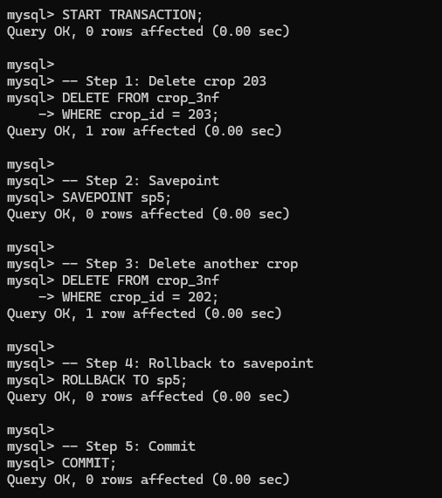

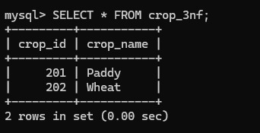

5.3 Concurrency control
Concurrency control is used to manage multiple transactions executing at the same time without causing data inconsistency.
In the Smart Agriculture & Farmer Assistance System (SAFAS), multiple users such as farmers, agriculture officers, and government admins may access or update the database simultaneously. Concurrency control ensures that these operations do not conflict with each other.
It helps to:

Maintain data consistency
Prevent data loss
Avoid conflicts between transactions
5.3.1 Concurrency control Algorithms
Concurrency control algorithms ensure correct execution of transactions. The most commonly used technique is locking.
Locking prevents multiple transactions from accessing the same data simultaneously in conflicting ways.
5.3.1 Locking commands
a. Row-Level Locking – SELECT ... FOR UPDATE
This locks only specific rows in a table.
START TRANSACTION;
SELECT * FROM farmer_3nf
WHERE farmer_id = 1
FOR UPDATE;
Explanation:
Locks only the selected row
Other transactions cannot modify this row until commit
b. Table-Level Locking – LOCK TABLE
This locks the entire table.
LOCK TABLES farmer_3nf WRITE;
Explanation:
No other transaction can read/write the table
Used when full control is required

Lock Mode | Description
ROW SHARE | Allows concurrent access; prevents other sessions from locking the table exclusively.
ROW EXCLUSIVE | Prevents other sessions from locking in share mode. Used by default for DML.
SHARE | Allows queries but not updates or deletes.
SHARE ROW EXCLUSIVE | A mix; more restrictive than SHARE.
EXCLUSIVE | Prevents all other access — full table lock.

c. COMMIT – Release All Locks
COMMIT;
Explanation:
Saves changes
Releases all locks
d. ROLLBACK – Undo Changes & Release Locks
ROLLBACK;
Explanation:
Cancels changes
Releases locks

5.3.2 Example
Scenario:
Two users try to update the same farmer record
Transaction -1
START TRANSACTION;
SELECT * FROM farmer_3nf
WHERE farmer_id = 1
FOR UPDATE;
UPDATE farmer_3nf
SET farmer_name = 'Ravi Updated'
WHERE farmer_id = 1;
Transaction -2
START TRANSACTION;
UPDATE farmer_3nf
SET farmer_name = 'Conflict Name'
WHERE farmer_id = 1;
Behaviour:
Transaction 2 will wait (blocked)
Because Transaction 1 locked the row
Final Step
COMMIT;

Final Output:
SELECT farmer_id, farmer_name
FROM farmer_3nf
WHERE farmer_id = 1;
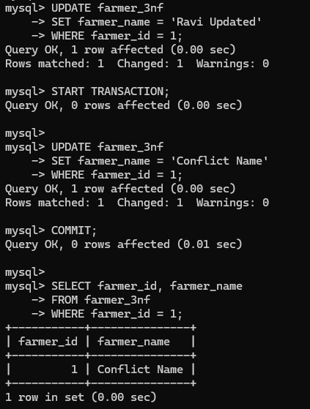

CHAPTER 6
FRONT-END AND BACK-END CODE OF SMART AGRICULTURE FARMER ASSISTANCE SYSTEM
6.1 Front–End Module codes

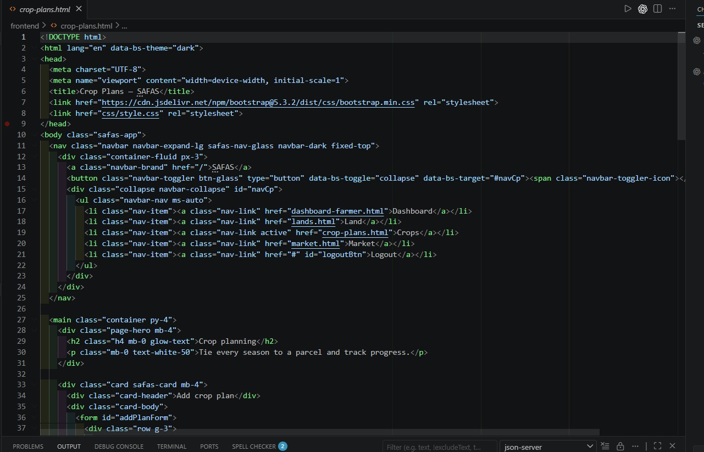
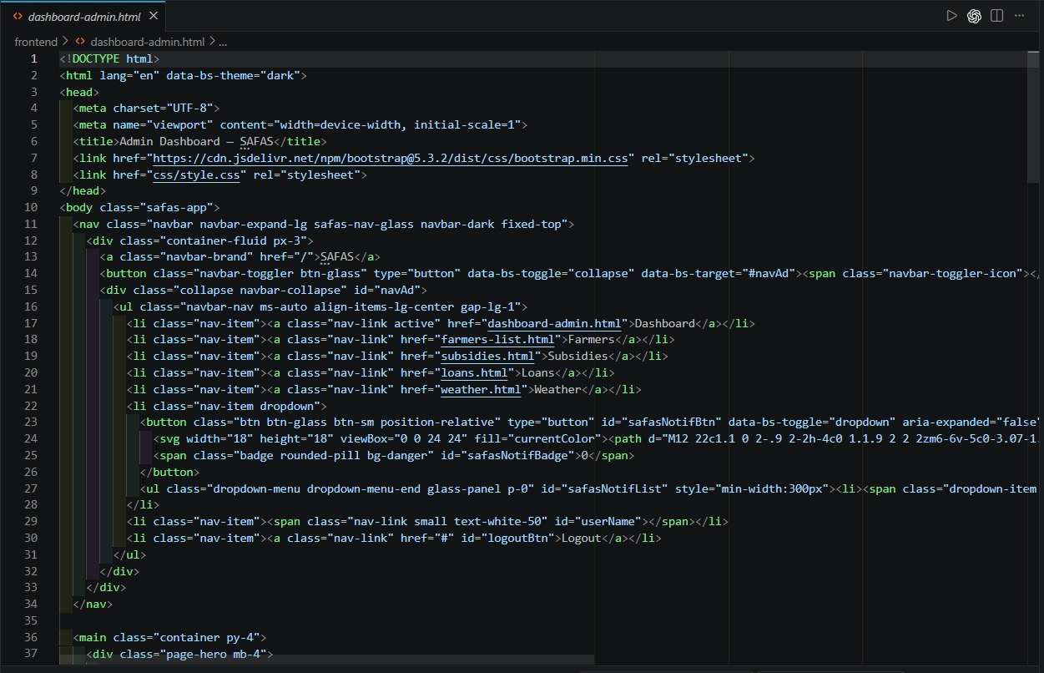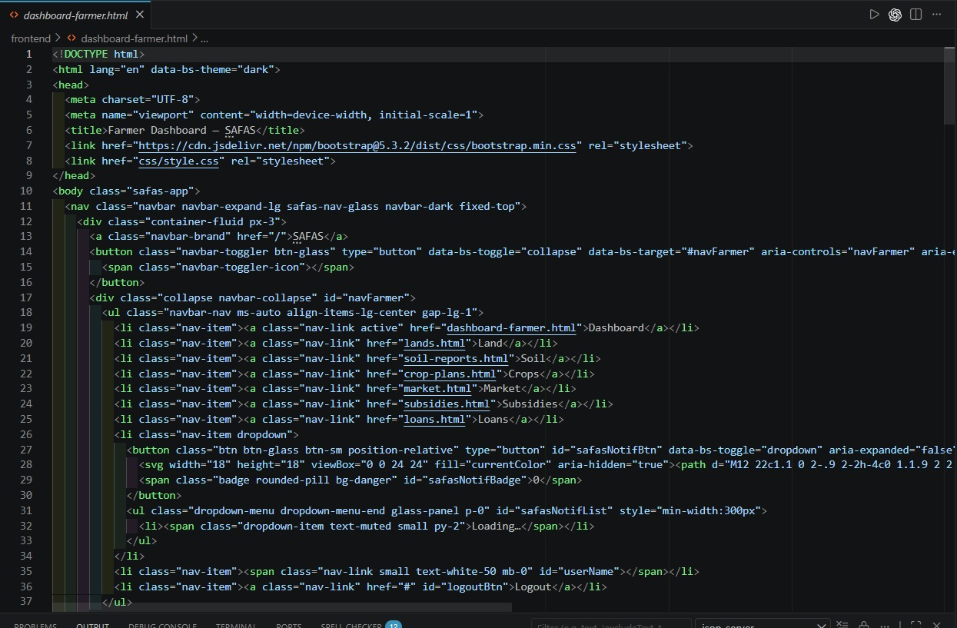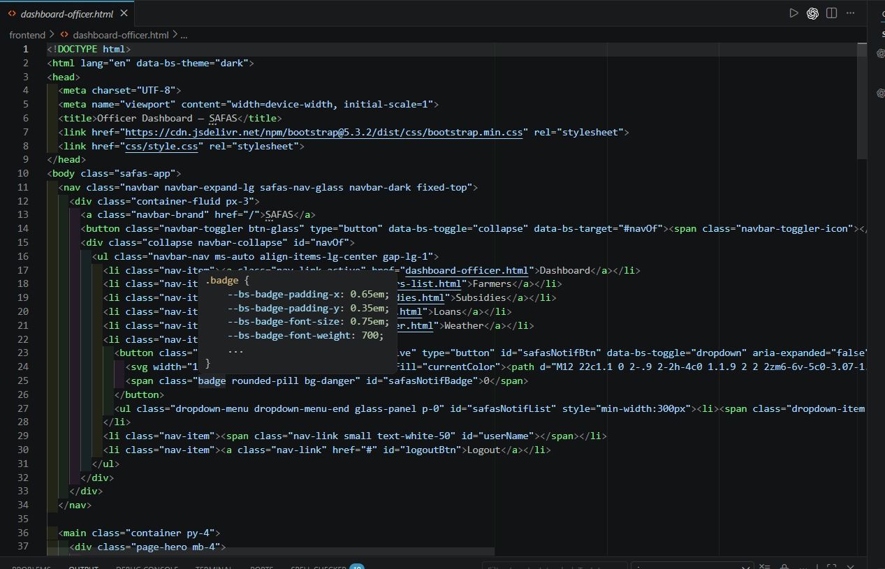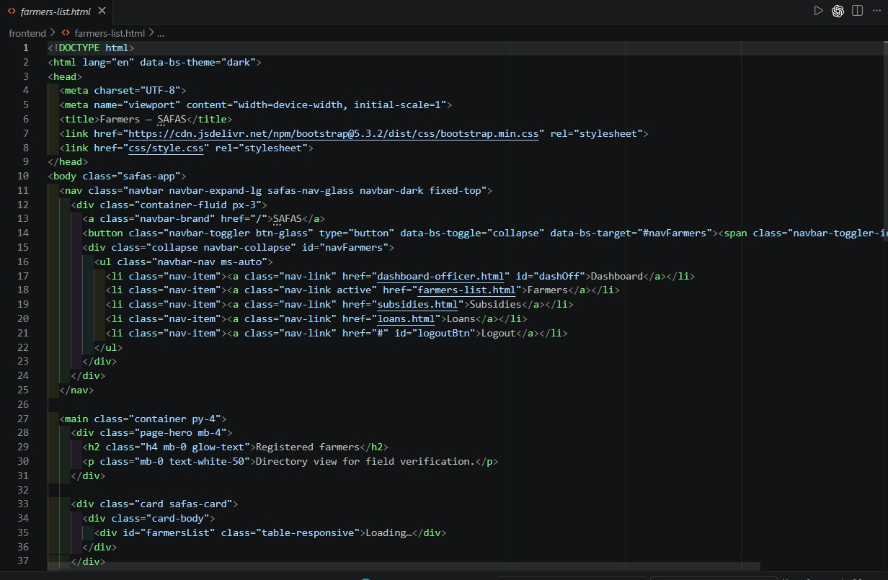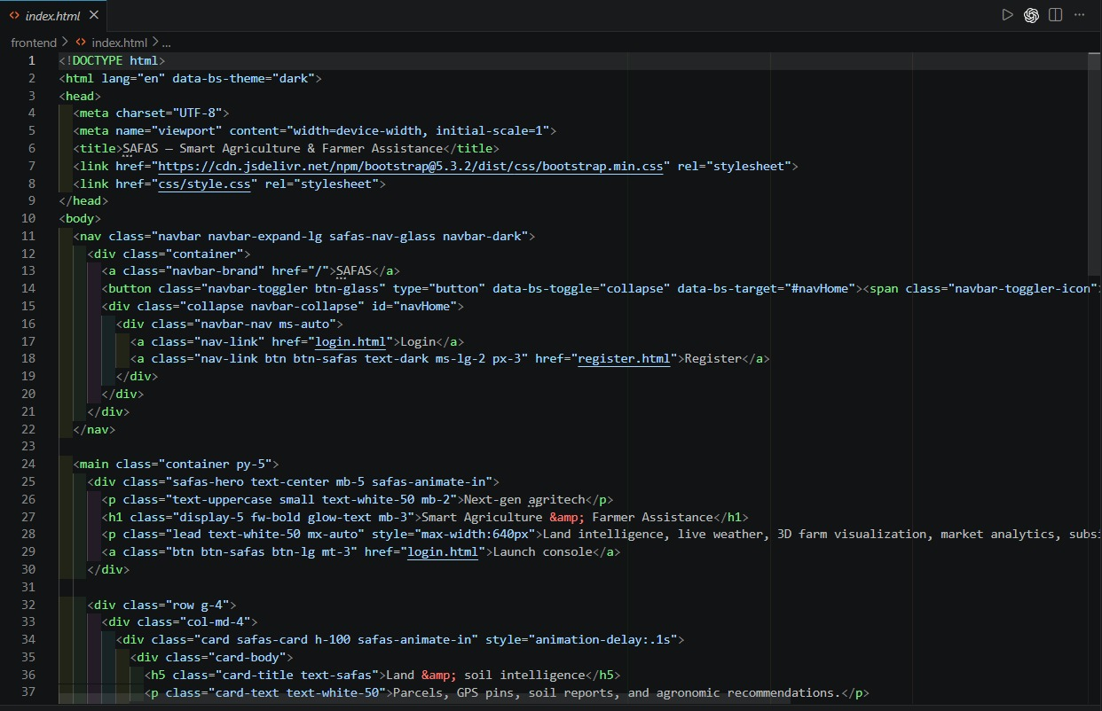

6.2 Database connectivity
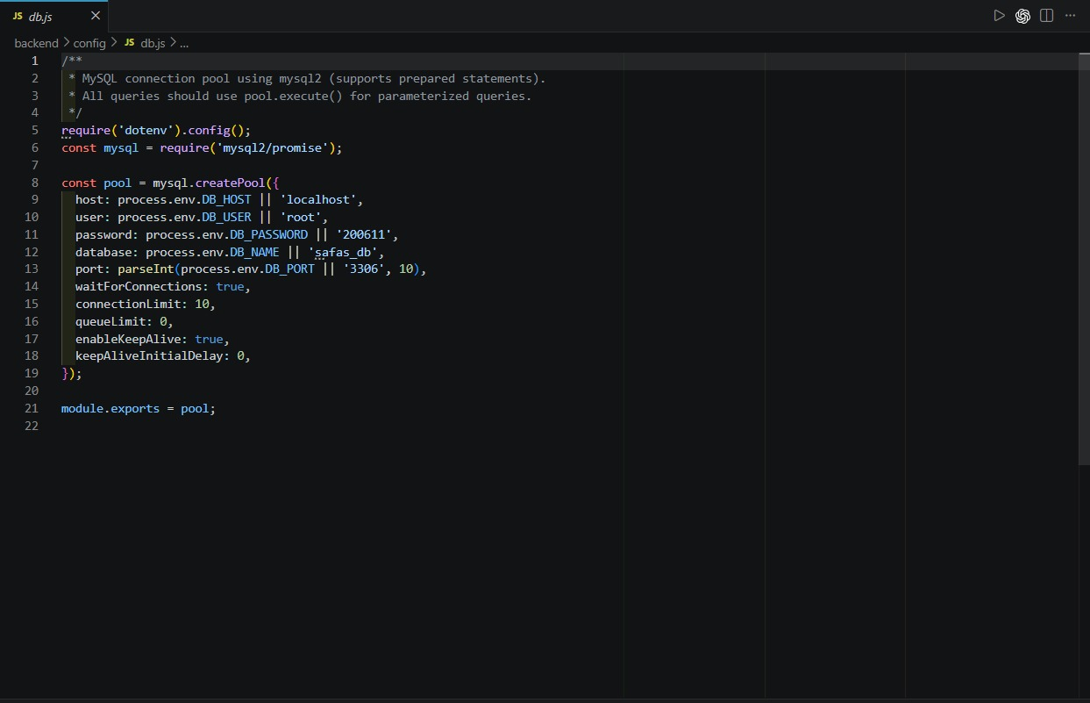
CHAPTER 7
RESULTS AND DISCUSSIONS

7.1 Screenshots of front-end
DASHBOARD PAGE
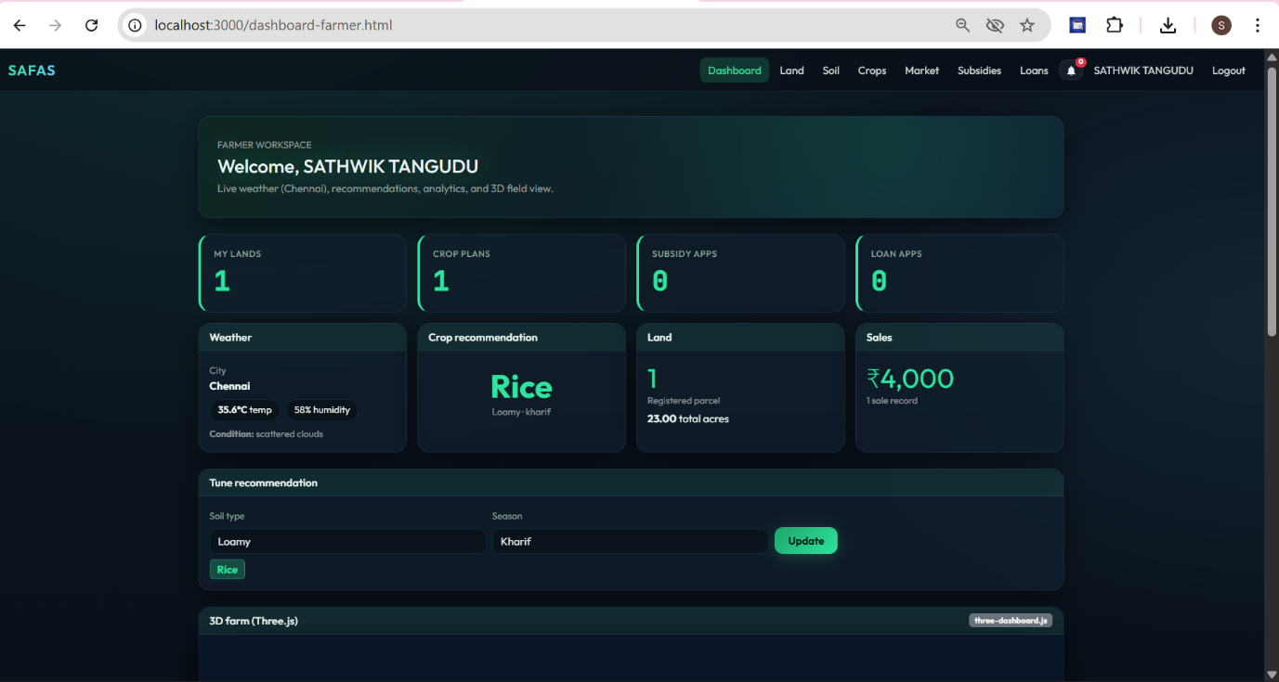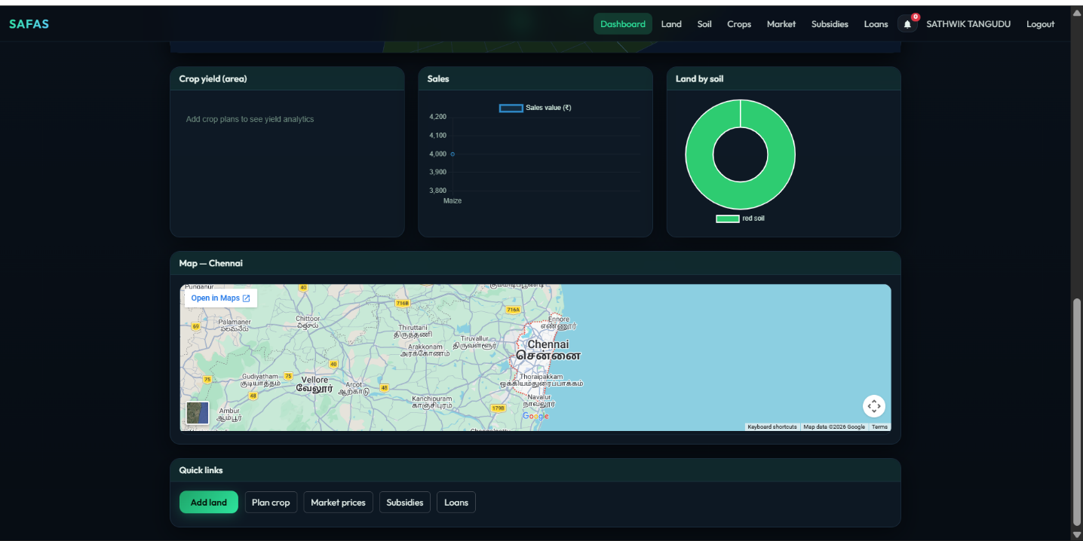

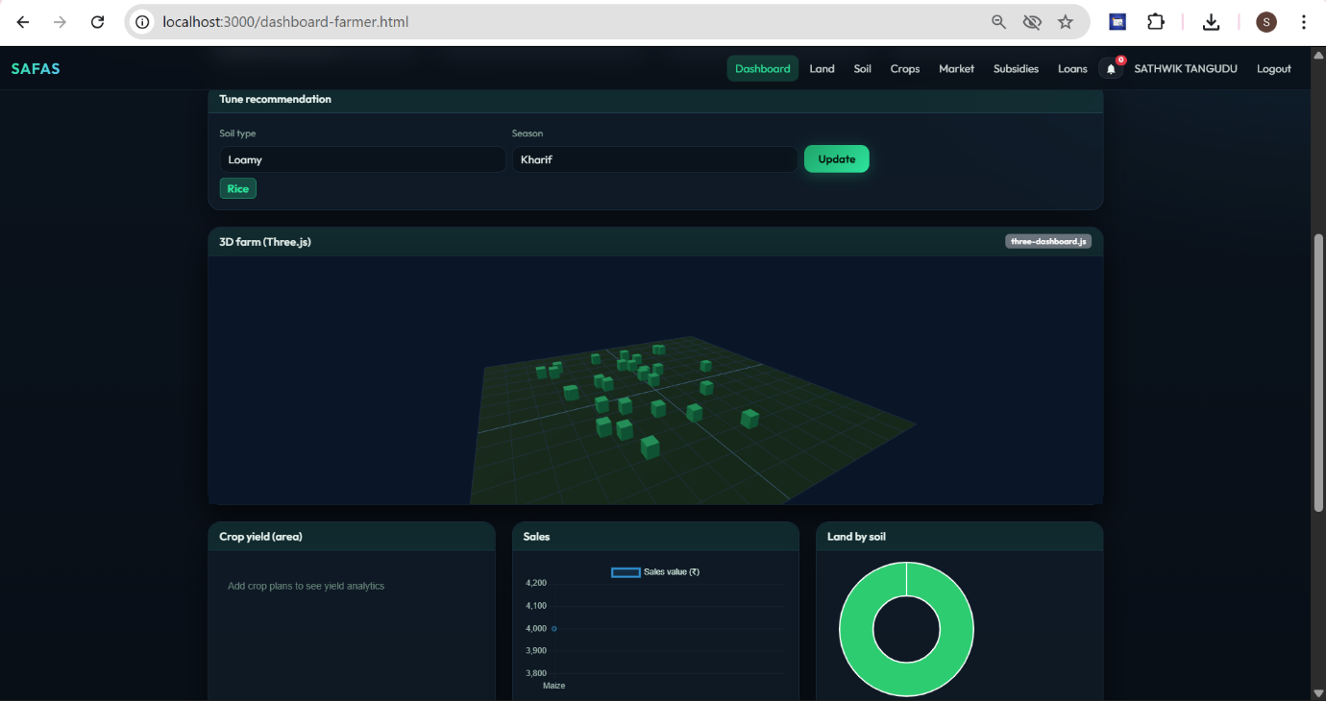
LAND PAGE
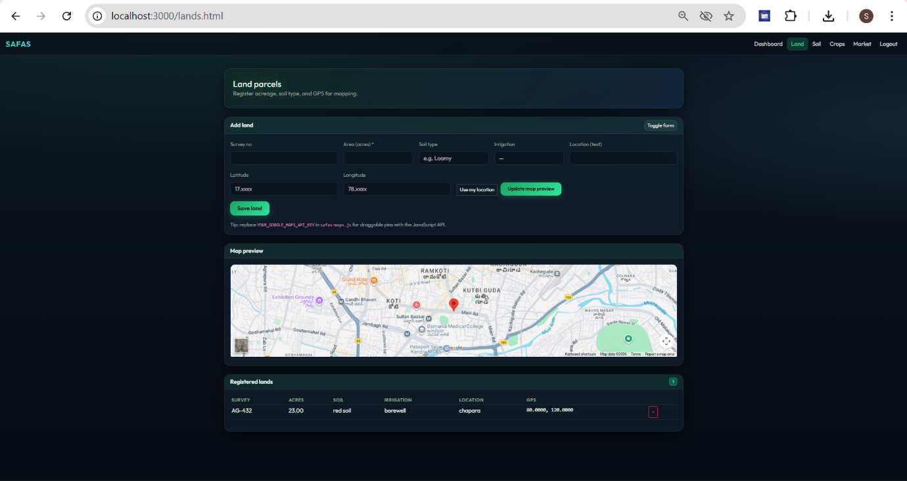

SOIL PAGE
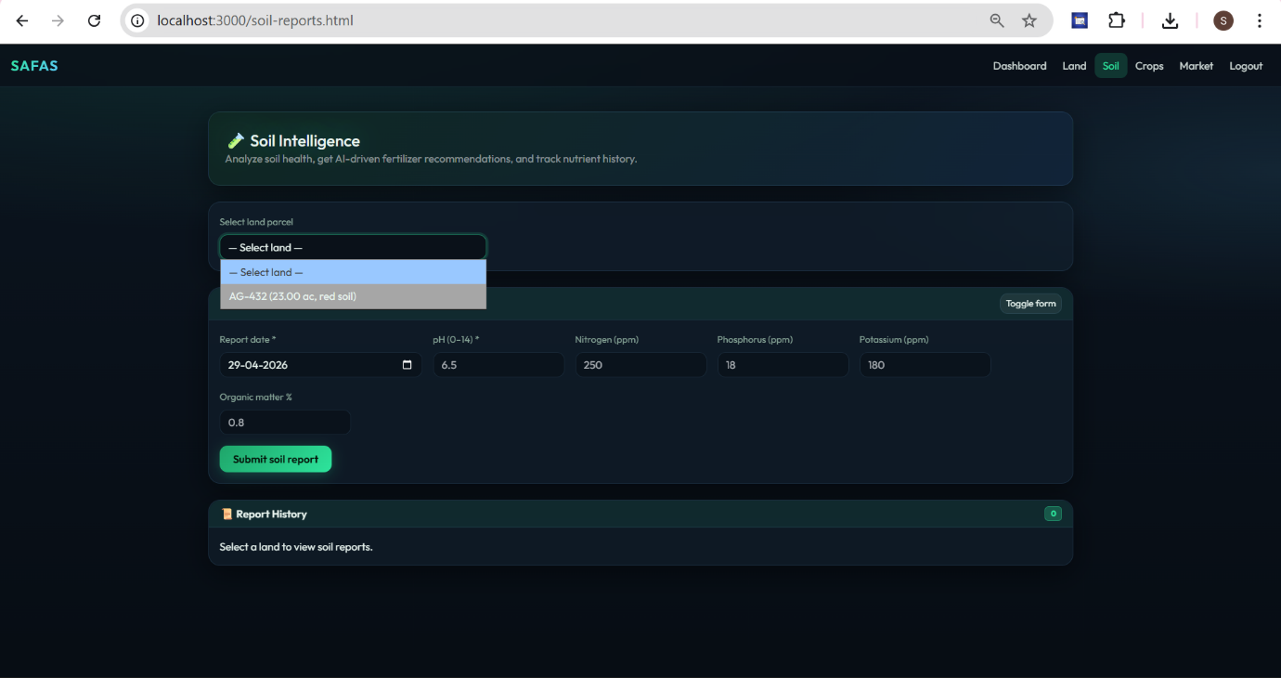
CROP PAGE
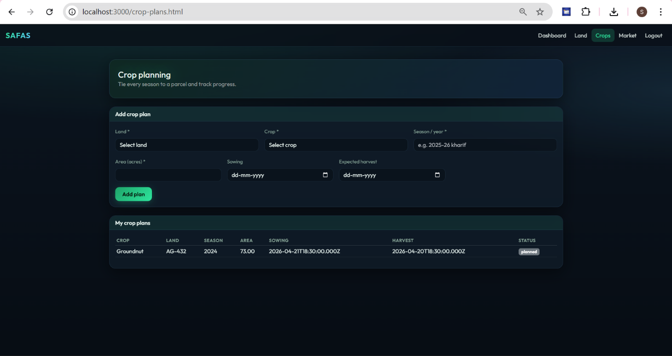

MARKET PAGE
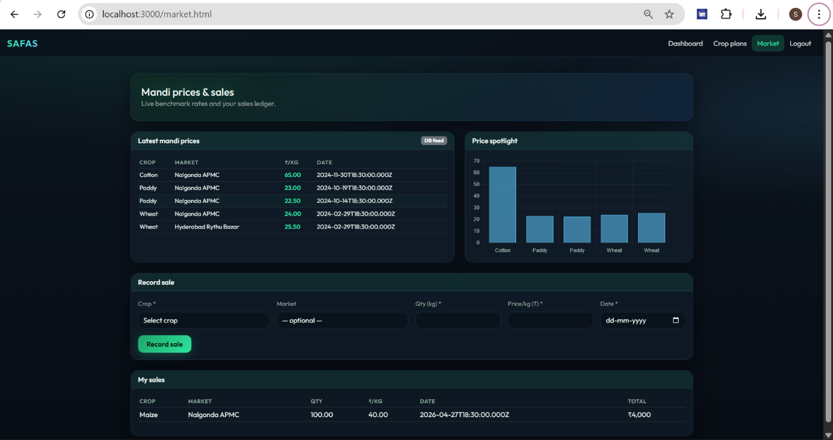
SUBSIDY PAGE
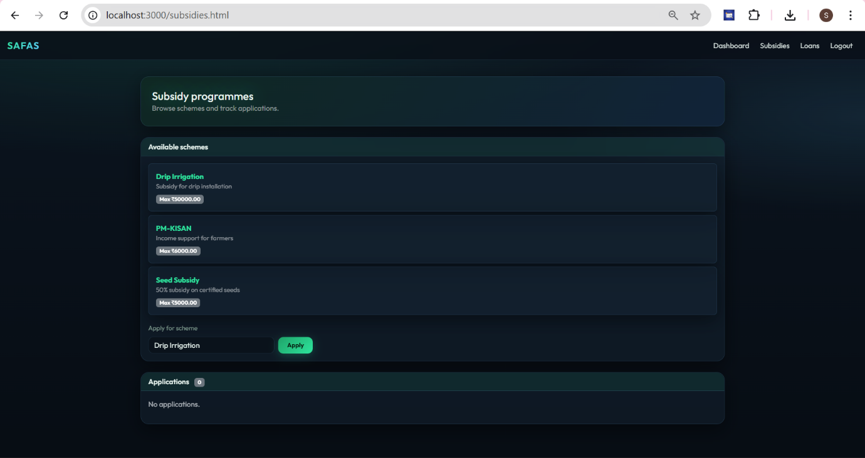

LOAN PAGE
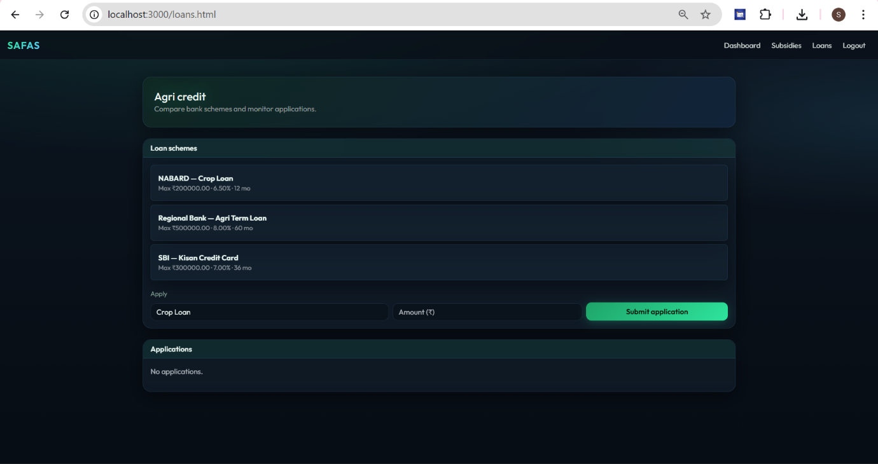

7.2 Screenshots of Database
DATABASE TABLES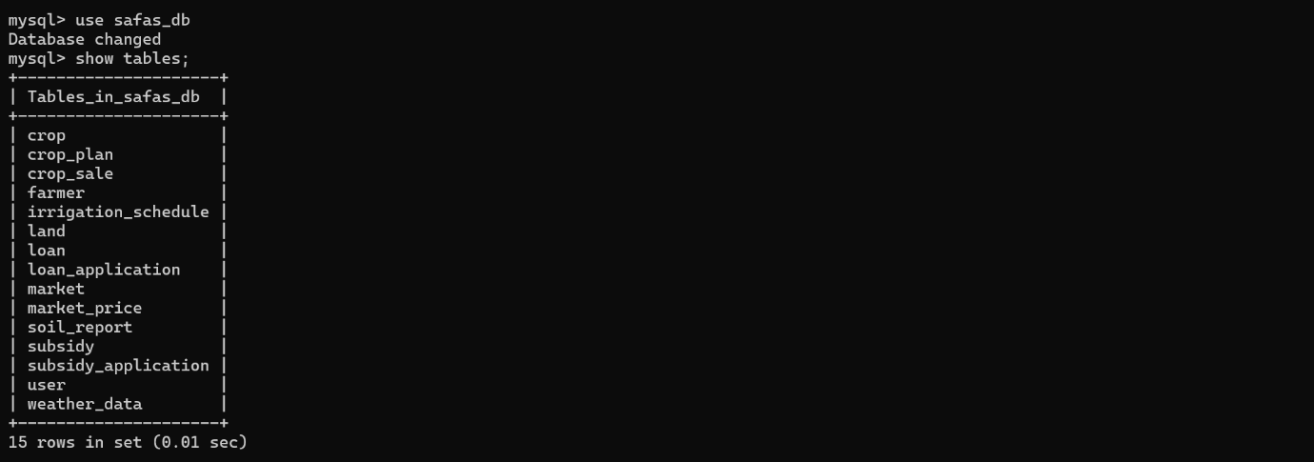
CROP TABLES
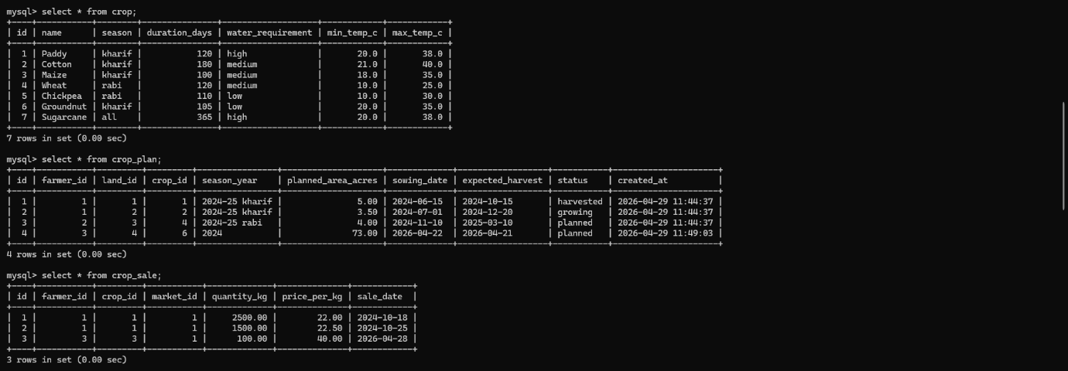
WEATHER TABLE
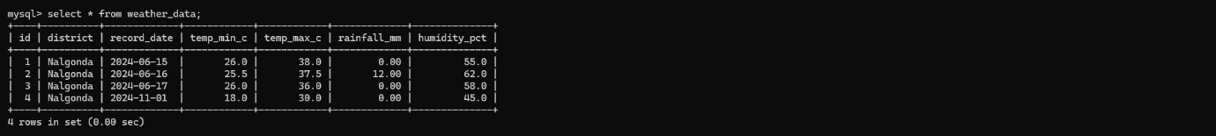
USER TABLE
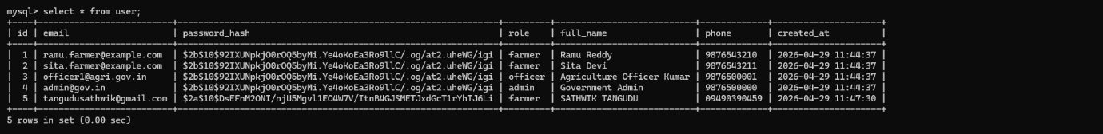

SOIL TABLE
SUBSIDY TABLE
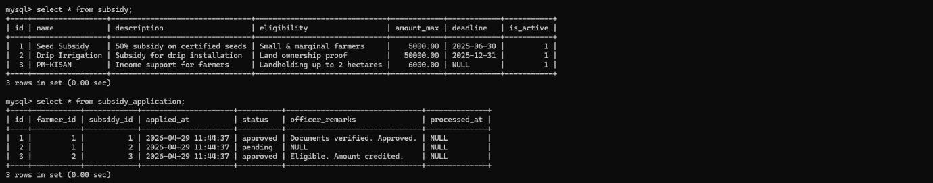
MARKET TABLE
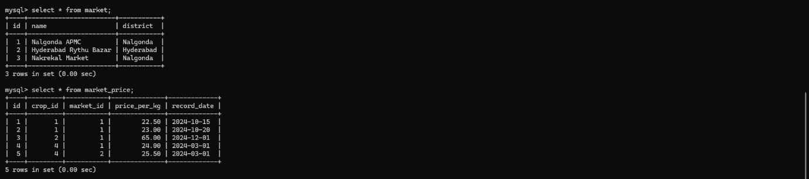
LOAN TABLE
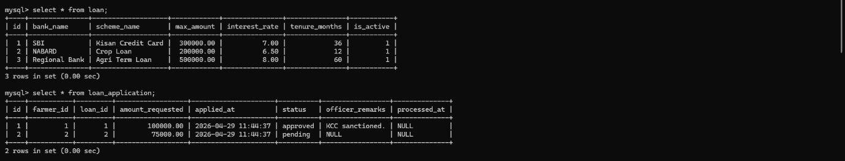
LAND TABLE
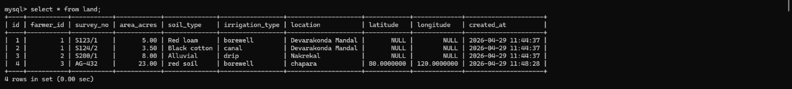
FARMER TABLE
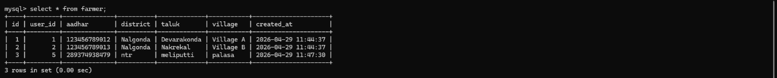

References
- Silberschatz, A., Korth, H. F., & Sudarshan, S. (2020). Database System Concepts (7th ed.). McGraw-Hill Education.
- Elmasri, R., & Navathe, S. B. (2017). Fundamentals of Database Systems (7th ed.). Pearson.
- Ramakrishnan, R., & Gehrke, J. (2003). Database Management Systems (3rd ed.). McGraw-Hill.
- MySQL Documentation. (2024). MySQL 8.0 Reference Manual.
- Ministry of Agriculture & Farmers Welfare, India. (2024). Various Government Schemes for Farmers.
Empty Spaces and Placeholders to Fill

